Inverse Functions

Why must the function be one-to-one for an inverse function to exist?

How do we find an inverse function?

Example Steps
- If $f\left(x\right)=3-4x$, find $f^{-1}(x)$

- If $f\left(x\right)=\frac{x+2}{2x-1}$, $x≠\frac{1}{2}$, determine $f^{-1}\left(x\right)$

Graphing an Inverse Function

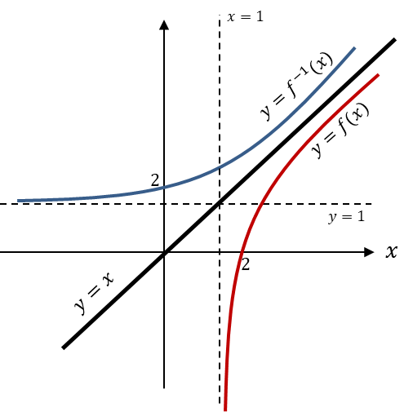
The domain of $f\left(x\right)$ is the range of $f^{-1}\left(x\right)$ and vice versa.

Example
If $g(x)$ is defined as $g\left(x\right)=\sqrt{x-2} \left\{x∈R,x≥2\right\}$
- Find the range of $g\left(x\right)$.

- Calculate $g^{-1}\left(x\right)$

- Sketch the graphs of both functions.

- State the domain and range of $g^{-1}\left(x\right)$.
Test your understanding
The function $f$ is defined by
$f:x→e^{x}+2$, $x∈R$
(a) Find $f^{-1}$, the inverse function of $f$, stating its domain.

(b) On the same axe sketch the curves with equation $y=f\left(x\right)$ and $y=f^{-1}\left(x\right)$, giving the coordinates of all the points where the curves cross the axes.

Ex 2D Pg 38

