2D IQR & Other Ranges

- The table shows the masses (tonnes) of 120 African elephants.
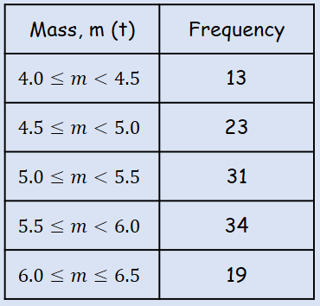
Find estimates for:
- The range

- The interquartile range

- The 10th to 90th percentile range

