Other measures of location
Quartiles
Listed Data
Items | $$n$$ | Position of LQ & UQ | LQ & UQ
$$1,4,7,9,10$$ | 5
$$4,9,10,15$$ | 4
$$2,4,5,7,8,9,11$$ | 7
$$1,2,3,5,6,9,9,10,11,12$$ | 10

Quartiles – Listed Data

Grouped Data
Items | $$n$$ | Position of LQ & UQ | LQ & UQ
$$1,4,7,9,10$$ | 5
$$4,9,10,15$$ | 4
$$2,4,5,7,8,9,11$$ | 7
$$1,2,3,5,6,9,9,10,11,12$$ | 10

Quartiles – Grouped Data

cv
Percentiles

cv
Notation
Lower Quartile: Median:
Upper Quartile: 57th Percentile:
Measures of Spread

Test your understanding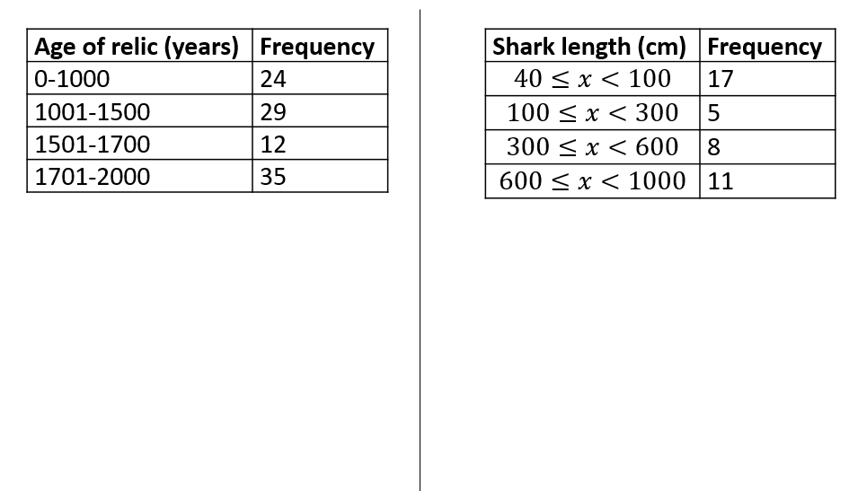

Q1) S1 May 2013 Q4 (continued)
The following table summarises the times, t minutes to the nearest minute, recorded for a group of students to complete an exam.
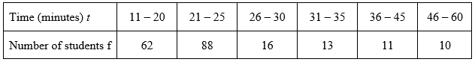

(c) Show that the estimated value of the lower quartile is 18.6 to 3 significant figures.

(1)
(d) Estimate the interquartile range of this distribution.

(2)

Q2) S1 June 2005 Q2
The following table summarises the distances, to the nearest km, that 134 examiners travelled to attend a meeting in London.
Distance (km) | Number of examiners
41–45 | 4
46–50 | 19
51–60 | 53
61–70 | 37
71–90 | 15
91–150 | 6

(c) Use interpolation to estimate the median Q₂, the lower quartile Q₁, and the upper quartile Q₃ of these data.
Q3) The ages of 300 houses in a village are recorded given the following table of results.
Age $a$ (years) | Number of houses
$$0≤a<20$$ | $$36$$
$$20≤a<40$$ | $$92$$
$$40≤a<60$$ | $$74$$
$$60≤a<100$$ | $$39$$
$$100≤a<200$$ | $$14$$
$$200≤a<300$$ | $$27$$
$$300≤a<500$$ | $$18$$
Use linear interpolation to estimate the lower quartile, upper quartile and hence the interquartile range.

Q4)
A cyber-café recorded how long each user stayed during one day giving the following results.
Length of stay (minutes) | Number of houses
$$0≤l<30$$ | $$15$$
$$30≤l<60$$ | $$31$$
$$60≤l<90$$ | $$32$$
$$90≤l<120$$ | $$23$$
$$120≤l<240$$ | $$17$$
$$240≤l<360$$ | $$2$$

Use linear interpolation to estimate:
- The lower quartile.

- The upper quartile.

- The 90th percentile.

Q5)
Distance  (to the nearest mile) | Number of  commuters
0 – 9 | 10
10 – 19 | 19
20 – 29 | 43
30 – 39 | 25
40 – 49 | 8
50 – 59 | 6
60 – 69 | 5
70 – 79 | 3
80 – 89 | 1

Find the interquartile range for the distance travelled by commuters.

