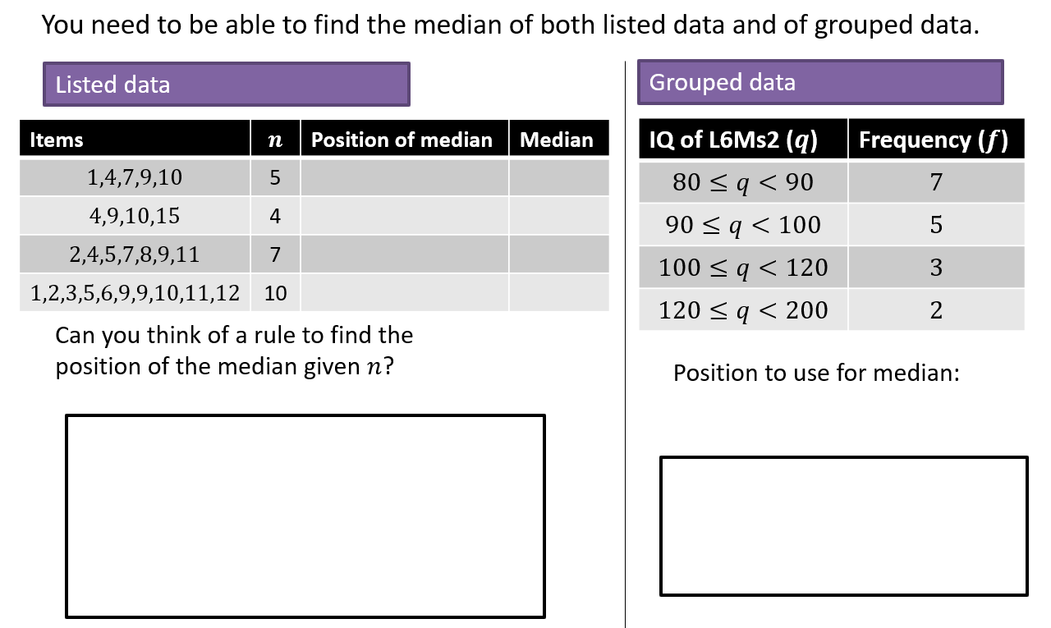
Finding the Median
Linear Interpolation

Formula

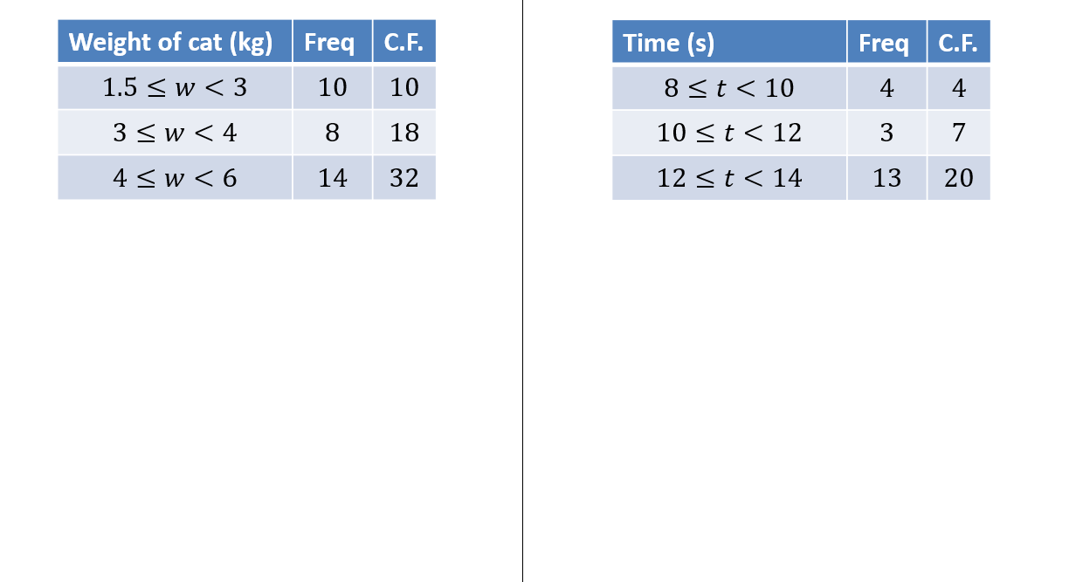
Examples
Class width
Weight of cat to nearest kg | Frequency
$$10-12$$ | $$7$$
$$13-15$$ | $$2$$
$$16-18$$ | $$9$$
$$19-20$$ | $$4$$

Linear Interpolation with gaps
Example
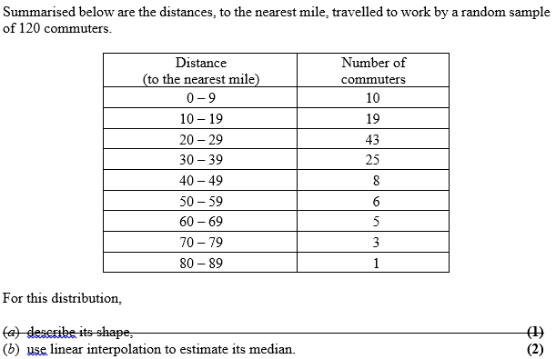
Test Your Understanding
Use linear interpolation to estimate the median of the following:
Age of relic (years) | Frequency
0-1000 | 24
1001-1500 | 29
1501-1700 | 12
1701-2000 | 35
1)

Shark length (cm) | Frequency
$$40≤x<100$$ | 17
$$100≤x<300$$ | 5
$$300≤x<600$$ | 8
$$600≤x<1000$$ | 10
2)

Supplementary Exercise 1
Q1) Solomon Paper A Q5b
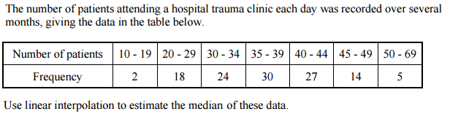

Q2) Solomon Paper E Q4a
The ages of 300 houses in a village are recorded given the following table of results.
Age $a$ (years) | Number of houses
$$0≤a<20$$ | $$36$$
$$20≤a<40$$ | $$92$$
$$40≤a<60$$ | $$74$$
$$60≤a<100$$ | $$39$$
$$100≤a<200$$ | $$14$$
$$200≤a<300$$ | $$27$$
$$300≤a<500$$ | $$18$$
Use linear interpolation to estimate the median.

Q3) Solomon Paper L Q7a
A cyber-café recorded how long each user stayed during one day giving the following results.
Length of stay (minutes) | Number of houses
$$0≤l<30$$ | $$15$$
$$30≤l<60$$ | $$31$$
$$60≤l<90$$ | $$32$$
$$90≤l<120$$ | $$23$$
$$120≤l<240$$ | $$17$$
$$240≤l<360$$ | $$2$$
Use linear interpolation to estimate the median of these data.

Q4) S1 May 2013 Q4
The following table summarises the times, t minutes to the nearest minute, recorded for a group of students to complete an exam.
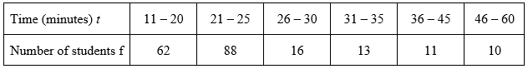
[You may use ∑ft² = 134281.25]

(a) Estimate the mean and standard deviation of these data. (5)

(b) Use linear interpolation to estimate the value of the median. (2)

Exercise 2C Pages 27-28

