2B Part 2 Solving Equations with Functions

- Given that the function g(x) = 2x² + 3, find;
- the value of g(3)

- the value(s) of a such that g(a) = 35

- the range of the function

- The function f(x) is defined by:
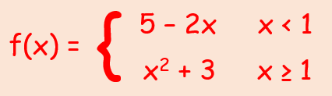
- Sketch f(x) stating its range
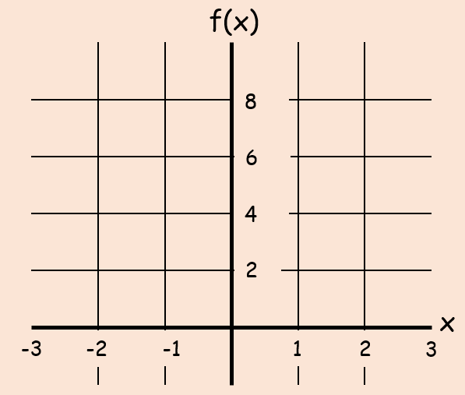

- Find the values of a such that f(a) = 19

