2B Part 1 Domains & Ranges
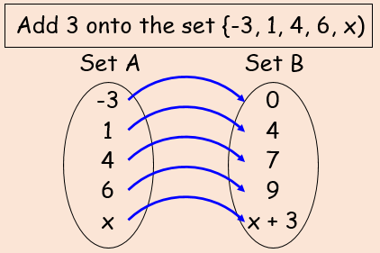

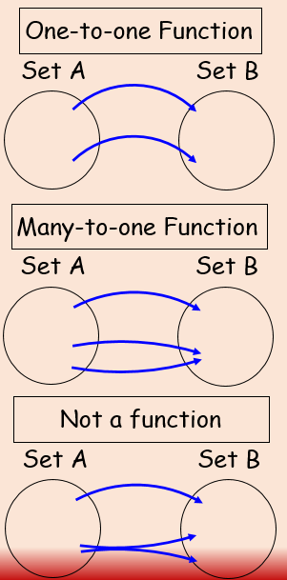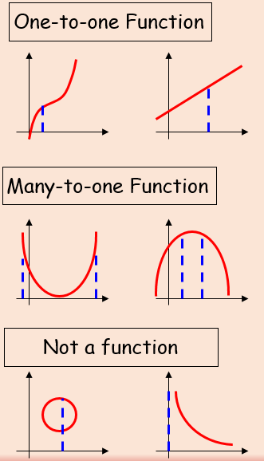

- Find the range of the following function, and state if it is one-to-one or many-to-one.
- f(x) = 3x – 2, domain {x = 1, 2, 3, 4}

- f(x) = 3x – 2, {x = 1, 2, 3, 4}

- g(x) = x², domain {x є R, -5 ≤ x ≤ 5}

- g(x) = x², {-5 ≤ x ≤ 5}

- h(x) = ¹/_{x}, domain {x є R, 0 < x ≤ 3}

- h(x) = ¹/_{x}, {x є R, 0 < x ≤ 3}

