Mappings
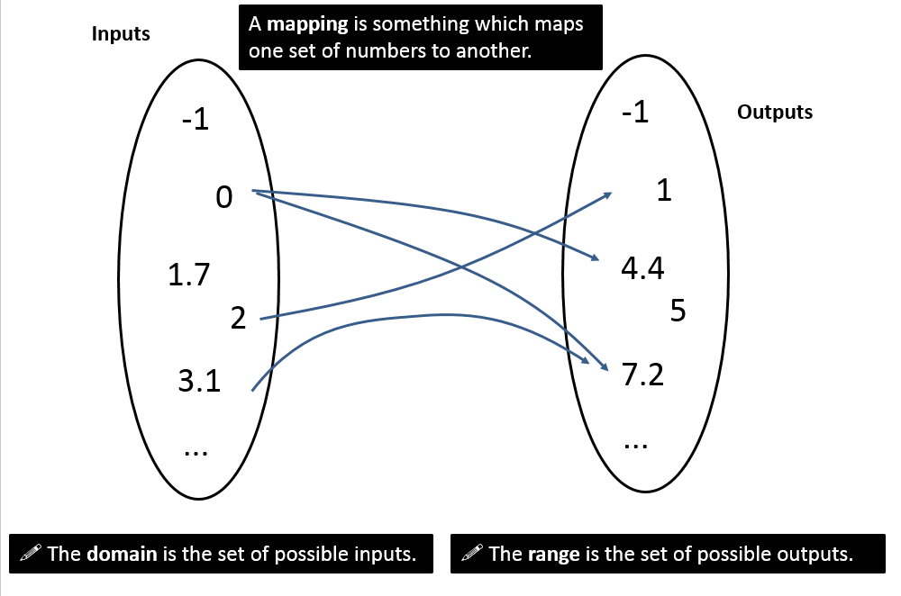

Types of Mappings

Functions

Type | Description | Example
Many-to-one Function
One-to-one Function

Which of these are functions?

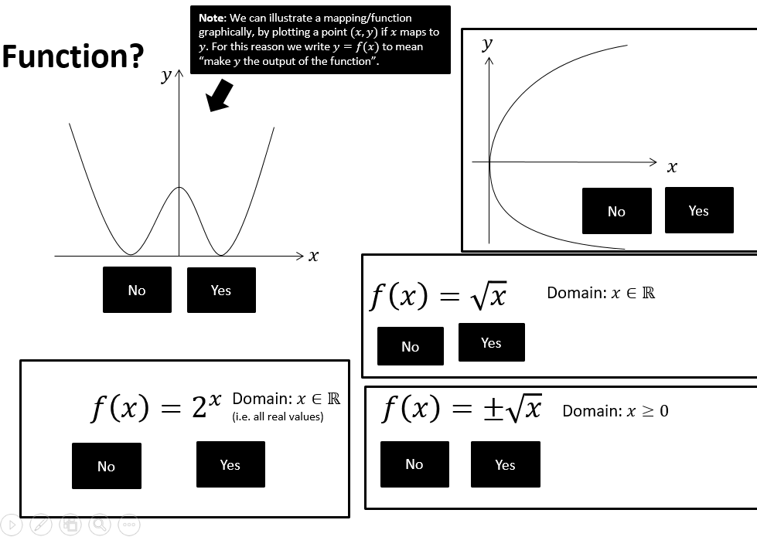

Domain and Range
Remember:

The domain is ……………………………………………………………………………………………………

The range is ……………………………………………………………………………………………………..

Using a sketch, try to identify the range of the following functions.
- $f\left(x\right)=x^{2}, x∈R$

- $f\left(x\right)=\frac{1}{x}, x∈R, x≠0$

- $f\left(x\right)=\ln{x}, x∈R, x>0$

- $f\left(x\right)=e^{x}, x∈R,$

- $f\left(x\right)=x^{2}+2x+9, x∈R$

- $f\left(x\right)=x^{2}, x∈R, -1≤x≤4$

Further Example

Find the range of each of the following functions.
- $f\left(x\right)=3x-2$, domain $\{1,2,3,4\}$

- $g\left(x\right)=x^{2}$, domain $\left\{x∈R, -5≤x≤5\right\}$

- $h\left(x\right)=\frac{1}{x}$, domain $\{x∈R, 0<x≤3$}
State if the functions are one-to-one or many-to-one.

