2AB Mean Median Mode

- The mean of a sample of 25 observations is 6.4. The mean of a second sample of 30 observations is 7.2. Calculate the mean of all 55 observations.

- The mean of a sample of 25 observations is 6.4. The mean of a second sample of 30 observations of 7.2. Calculate the mean of all 55 observations.

- Rebecca records the shirt collar size, x, of the male students in her year. The results are shown in the table.
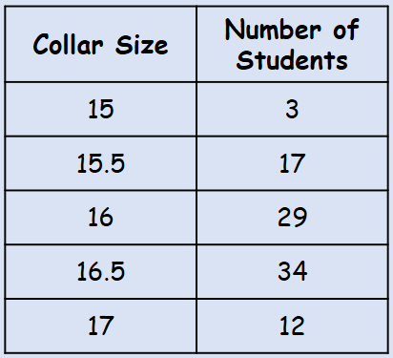
For the data, calculate:
- The mode

- The median

- The mean

- Explain why a shirt manufacturer might use the mode for setting their production quota

- The length, $x$ mm, to the nearest mm, of a random sample of pine cones is measured. The data is shown in the table to the right.
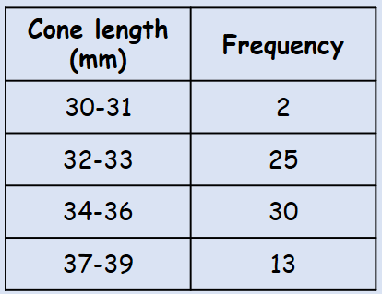
- Write down the modal class

- Estimate the mean

- Find the median class

