A Level Mathematics

Chapter 2 - Statistics
Measures of Location and Spread

Chapter Overview
- Measures of Central Tendency
- Other measures of location
- Measures of Spread
- Variance and Standard Deviation
- Coding
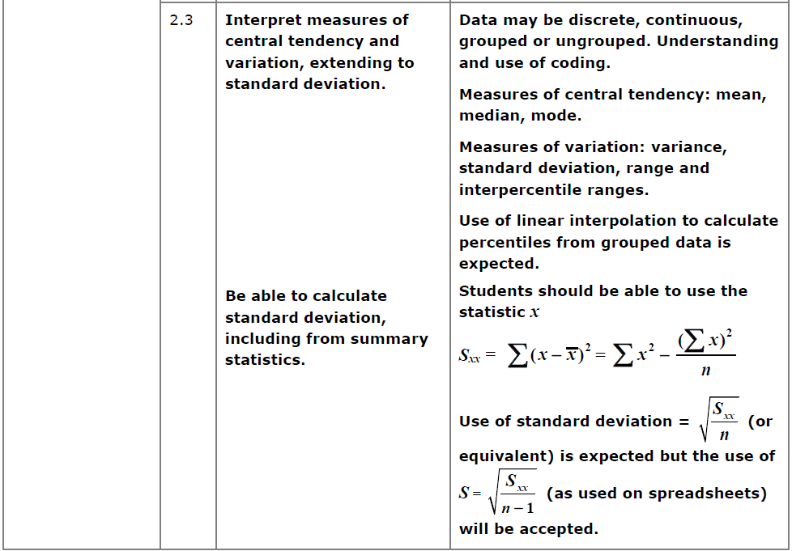

- Measure of Central Tendency

Measures of…

Finding the mean
Using your calculator
On a Classwiz:
- Select 1-Variable.
- Enter each value above, pressing = after each entry.
- Press AC to start a statistical calculation.
- Press the OPTN button. “1-Variable Calc” will calculate all common statistics (including all on the left). Alternatively, you can construct a statistical expression yourself – in the OPTN menu press Down. “Variable” for example contains $\overline{x}$. This will insert it into your calculation; press = when done.

Grouped Data

Mini-Exercise
1.

2.

3.

Exercise 2A/2B Pages 22-23, 24-25

Combined Mean
Example
The mean maths score of 20 pupils in class A is 62.
The mean maths score of 30 pupils in class B is 75.
- What is the overall mean of all the pupils’ marks.
- The teacher realises they mismarked one student’s paper; he should have received 100 instead of 95. Explain the effect on the mean and median.

Question
Archie the Archer competes in a competition with 50 rounds. He scored an average of 35 points in the first 10 rounds and an average of 25 in the remaining rounds. What was his average score per round?

