2A The |Modulus| Function

- The function f(x) is defined
$$f(x)=\left|2x-3\right|+1$$

find:

- f(5)

- -1)

- a) Sketch the graph of $y=\left|3x-2\right|$
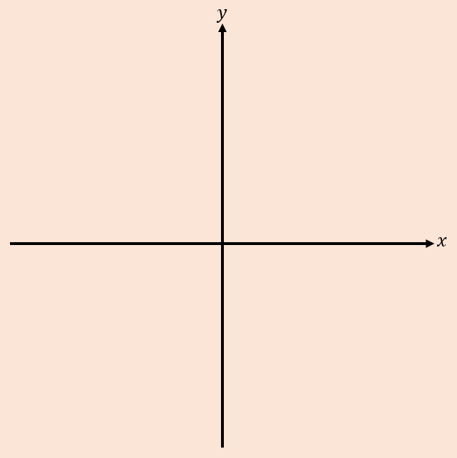

- Solve the equation $\left|2x-1\right|=5$

- Solve the equation $\left|3x-5\right|=2-\frac{1}{2}x$

- Solve the inequality $\left|5x-1\right|>3x$

