Upper 6 Chapter 2

Functions and Graphs

Chapter Overview

1. The Modulus Function

2. Mappings vs Functions, Domain and Range

3. Composite Functions

4. Inverse Functions

5. Transformations of the form $y=|f\left(x\right)|$ or $y=f\left(\left|x\right|\right)$. Combined transformations and transforming the modulus function.

6. Solving modulus problems







The Modulus Function

Example:

1. If , find



$f(5)$

$f(-2)$

$f(1)$

Modulus Graphs

|  |  |  |  |  |  |
| --- | --- | --- | --- | --- | --- |
| $$x$$ | -2 | -1 | 0 | 1 | 2 |
| $$y$$ |  |  |  |  |  |

$y=|x|$

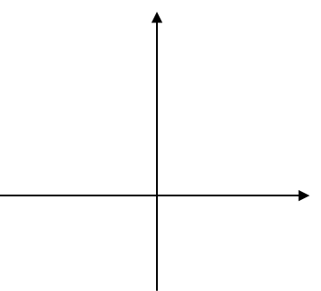Examples

1. Sketch

2. Solve



3. Solve

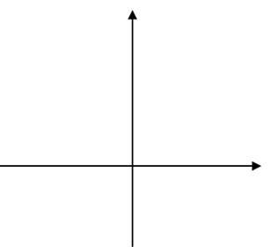

Test Your Understanding

1. Solve



2. Solve



Ex 2a page 18