2A Set Notation
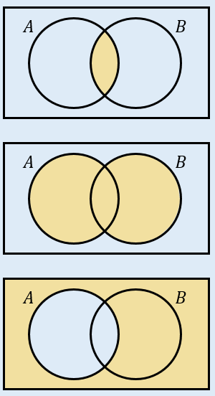

- A card is selected at random from a standard pack of playing cards. Let A be the event that the card is an Ace, and D be the event that the card is a diamond.
- Draw a Venn diagram to represent this information.

Find:
- $P\left(A∩D\right)$

- $P\left(A∪D\right)$

- $P\left(A^{'}\right)$

- $P(A^{'}∩D)$

- Given that $P\left(A\right)=0.3$, $P\left(B\right)=0.4$ and $P\left(A∩B\right)=0.25$.
- Explain why events $A$ and $B$ are not independent

- Given also that $P\left(C\right)=0.2$, events $A$ and C are mutually exclusive, and events B and C are independent, draw a Venn diagram to represent the situation

- Find $P\left(\left(A∩B^{'}\right)∪C\right)$

