2AB Mean Median Mode

- The mean of a sample of 25 observations is 6.4. The mean of a second sample of 30 observations is 7.2. Calculate the mean of all 55 observations.

- The mean of a sample of 25 observations is 6.4. The mean of a second sample of 30 observations of 7.2. Calculate the mean of all 55 observations.

- Rebecca records the shirt collar size, x, of the male students in her year. The results are shown in the table.
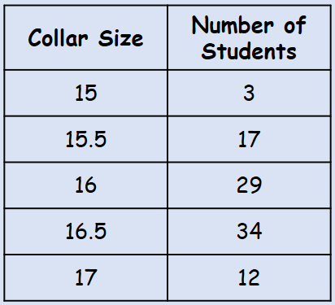
For the data, calculate:
- The mode

- The median

- The mean

- Explain why a shirt manufacturer might use the mode for setting their production quota

- The length, $x$ mm, to the nearest mm, of a random sample of pine cones is measured. The data is shown in the table to the right.
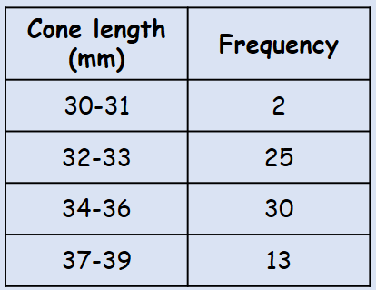
- Write down the modal class

- Estimate the mean

- Find the median class

2C Quartiles & Interpolation

- From the large data set, the daily maximum gust (knots) during the first 20 days of June 2015 is recorded in Hurn. The data is shown below:
14 | 15 | 17 | 17 | 18
18 | 19 | 19 | 22 | 22
23 | 23 | 23 | 24 | 25
26 | 27 | 28 | 36 | 39

Find the median and quartiles for this data.

- The length of time (to the nearest minute) spent on the internet each evening by a group of students is shown in the table below.
Time spent on internet (mins) | Frequency
30-31 | 2
32-33 | 25
34-36 | 30
37-39 | 13

- Find an estimate for the upper quartile

- Find an estimate for the 10th percentile

2D IQR & Other Ranges

- The table shows the masses (tonnes) of 120 African elephants.
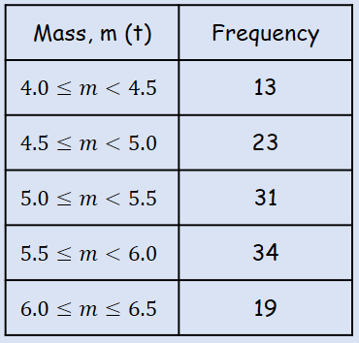
Find estimates for:
- The range

- The interquartile range

- The 10th to 90th percentile range

2E Variance & Standard Deviation

- The marks gained in a test by seven randomly selected students are:
x 3 4 6 2 8 8 5

Find the variance and standard deviation of the marks of the seven students.

- Shamsa records the time spent out of school during the lunch hour to the nearest minute, x, of the female students in her year. The results are shown in the table.
Calculate the standard deviation of the time spent out of school.
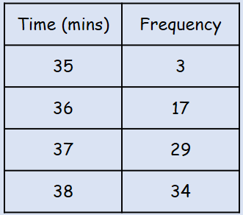

- Andy recorded the length, in minutes, of each telephone call he made for a month. The data is summarized in the table below.
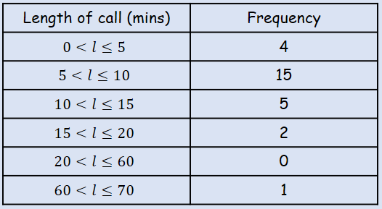
Calculate an estimate of the standard deviation of the length of the phonecalls

2F Coding

- A scientist measures the temperature, $x℃$ at five different points in a nuclear reactor. Her results are given below:
332, 355, 306, 317, 340
- Use the coding $y=\frac{x-300}{10}$ to code this data

- Calculate the mean and standard deviation of the coded data

- Use your answer to b) the calculate the mean and standard deviation of the original data.

- From the large data set, date on the maximum gust, $g$ knots, is recorded in Leuchars during May and June 2015.
The data was coded using $h=\frac{g-5}{10}$ and the following statistics found:
$$S_{hh}=43.58$$
$$\overline{h}=2$$
$$n=61$$
Calculate the mean and standard deviation of the maximum gust in knots.

