2A Set Notation
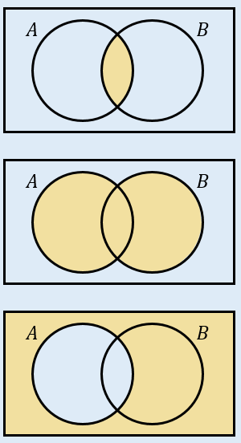

- A card is selected at random from a standard pack of playing cards. Let A be the event that the card is an Ace, and D be the event that the card is a diamond.
- Draw a Venn diagram to represent this information.

Find:
- $P\left(A∩D\right)$

- $P\left(A∪D\right)$

- $P\left(A^{'}\right)$

- $P(A^{'}∩D)$

- Given that $P\left(A\right)=0.3$, $P\left(B\right)=0.4$ and $P\left(A∩B\right)=0.25$.
- Explain why events $A$ and $B$ are not independent

- Given also that $P\left(C\right)=0.2$, events $A$ and C are mutually exclusive, and events B and C are independent, draw a Venn diagram to represent the situation

- Find $P\left(\left(A∩B^{'}\right)∪C\right)$

2B Conditional Probability

- A school has 75 students in year 12. Of these students, 25 study only humanities subjects (H), and 37 only study science subjects (S). 11 students study both types of subject.
- Draw a two-way table to show this information

Find:
- $P(S^{'}∩H^{'})$

- $P\left(S | H\right)$

- $P(H|S^{'})$
- Two four sided dice are thrown together, and the sum of the numbers shown is recorded.
- Draw a sample space diagram showing the possible outcomes

- Given that at least one dice lands on a 3, find the probability that the sum of the two dice is exactly 5

- State one modelling assumption used in your calculations

2C Conditional Probability in Venn Diagrams

- $A$ and $B$ are two events such that $P\left(A\right)=0.55$, $P\left(B\right)=0.4$ and $P\left(A∩B\right)=0.15$.
- Draw a Venn diagram showing the probabilities for events $A$ and $B$.

Find:
- $P\left(A | B\right)$

- $P\left(B | \left(A∪B\right)\right)$

- $P(A^{'}|B^{'})$

2D Probability Formulae

- A and B are two events, such that $P\left(A\right)=0.6$, $P\left(B\right)=0.7$ and $P\left(A∪B\right)=0.9$.
Find $P(A∩B)$.

- $C$ and $D$ are two events such that $P(C)=0.2$, $P(D)=0.6$ and $P(C|D)=0.3$.
Find:
- $P(C∩D)$

- $P(D|C)$

- $P(C∪D)$

2E Tree Diagrams

- A bag contains 6 green beads and 4 yellow beads. A bead is taken from the bag at random, the colour is recorded and it is not replaced. A second bead is then taken from the bag and its colour recorded. Given that both balls are the same colour, find the probability that they are both yellow.

