1E The Large Data Set
Dates:

Daily mean temperature

Daily total rainfall

Daily total sunshine

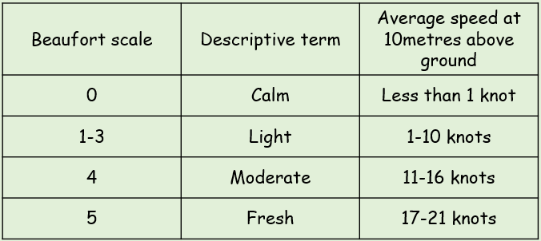
Daily mean wind direction and windspeed

Daily maximum gust

Daily maximum relative humidity

Daily mean cloud cover

Daily mean visibility

Daily mean pressure
- Look at the extract given
- Describe the type of data represented by daily total rainfall
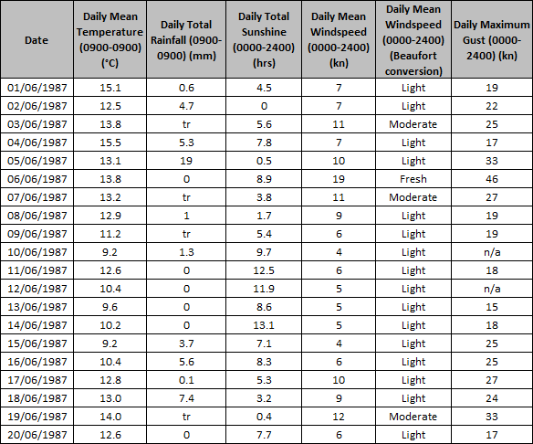
Alison is investigating daily maximum gust. She wants to select a sample size of size 5 from the first 20 days in Hurn in June 1987. She uses the first two digits of the date as the sampling frame and generates 5 random numbers from 1-20
- State the type of sampling method used

- Why might the method not generate a sample of size 5?

calculate:
- The mean daily mean temperature for the first 5 days of June in Hurn in 1987

- The median daily total rainfall for the week of 14th June to 20th June inclusive

The median daily total rainfall for the same week in Perth was 19.0mm. Karl states that more southerly countries experience higher rainfall during June
- State, with a reason, whether your answer to e) supports this statement

