1D Types of Data
Quantitative Data

Qualitative Data

Discrete Data

Continuous Data

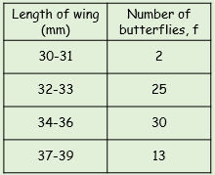
Class Boundaries

Midpoint

Class Width

- Is the length Qualitative or Quantitative?

- Is the length Discrete or Continuous?

- Write down the class boundaries, midpoint and class width for the class 34-36

