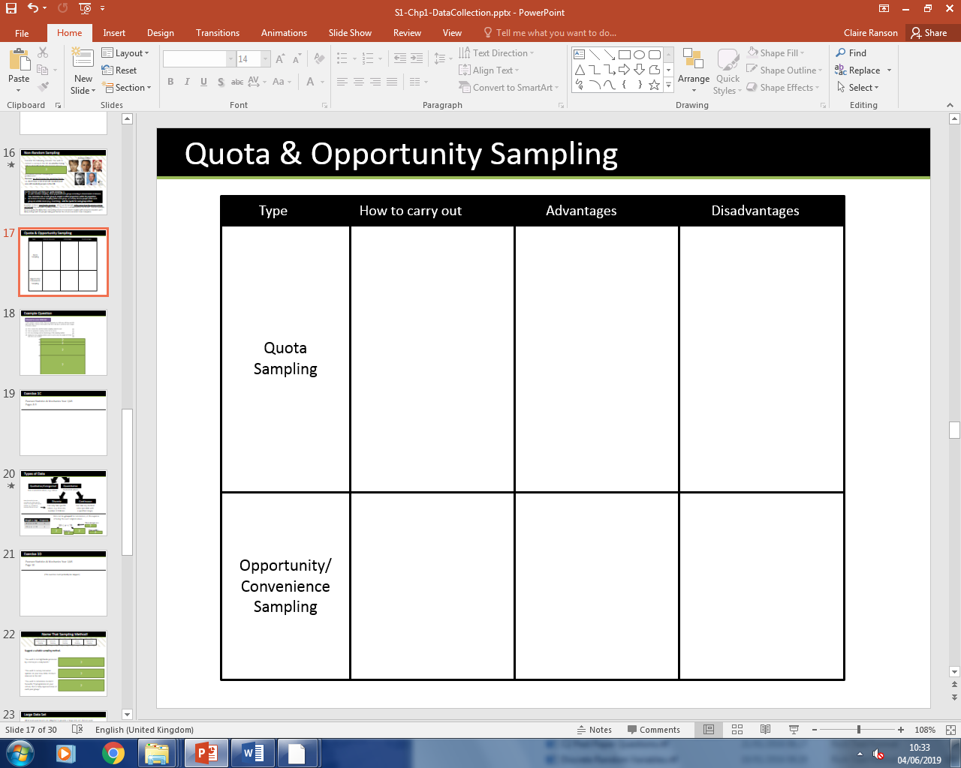Non-random Sampling

Example.

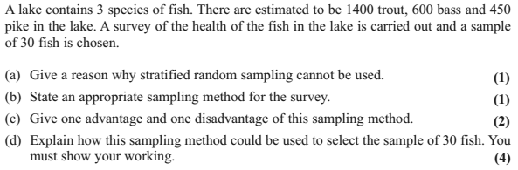

Exercise 1C Page 8