1B Random Sampling (Simple Random, Systematic & Statified)

Simple Random

Systematic

Stratified

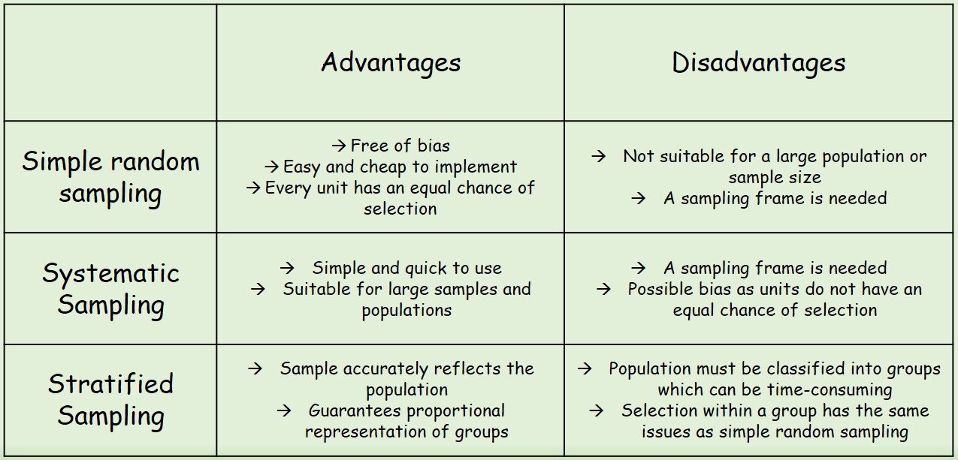
- A yacht club with 100 members are listed alphabetically in the club’s membership book. The committee wants to take a sample of 12 members to fill in a questionnaire.
- Explain how they could use a random number generator to generate the sample

- Explain how they could use a lottery system to generate the sample

- A factory manager wants to find out what his workers think of the canteen facilities. He decides to give a questionnaire to a sample of 80 workers. It is believed that different age groups will have different opinions.
The table to the right shows the number of workers in each age bracket.
- What sampling method should be used?
Age | Quantity
18-32 | 75
33-47 | 140
48-62 | 85

- How many workers should be selected from each age bracket?

