A Level Mathematics

Chapter 1 - Statistics
Data Collection

Chapter Overview
1. Populations and Samples
2. Sampling
3. Non-random Sampling
4. Types of Data
5. The Large Data Set
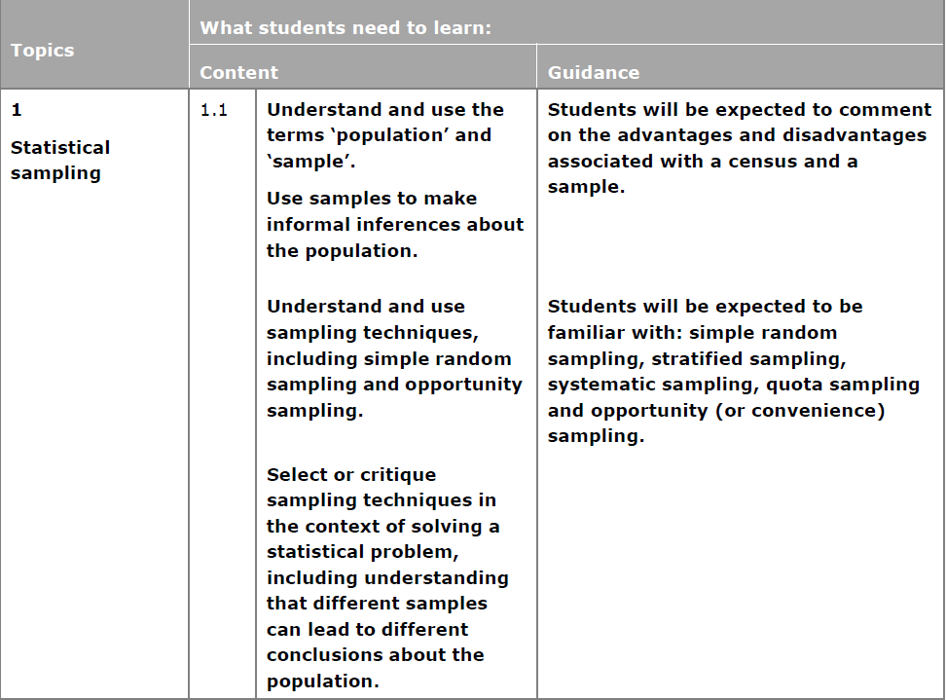
Populations and Samples
A population is –

A sample is –

A census is -

Key words:
Individual units of a population are called _________________. E.g. each individual person/item
Often sampling units of a population are individually named or numbered to form a list called a ________________. E.g. the list of all people/items
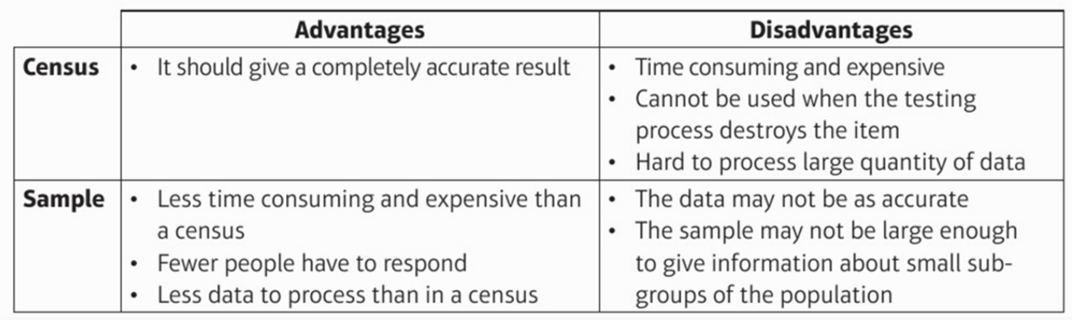
What are the advantages and disadvantages between taking a census and a sample?

Example: A supermarket wants to test a delivery of avocados for ripeness by cutting them in half.
- Suggest a reason why the supermarket should not test all the avocados in the delivery.
- The supermarket tests a sample of 5 avocados and finds that 4 of them are ripe. They estimate that 80% of the avocados in the deliver are ripe. Suggest one way that the supermarket could improve their estimate.

Exercise 1A Page 3

