10C Newton Raphson

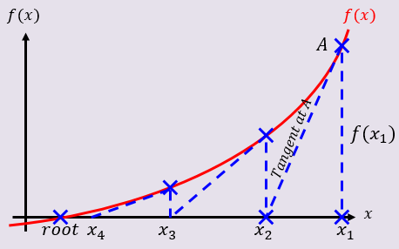

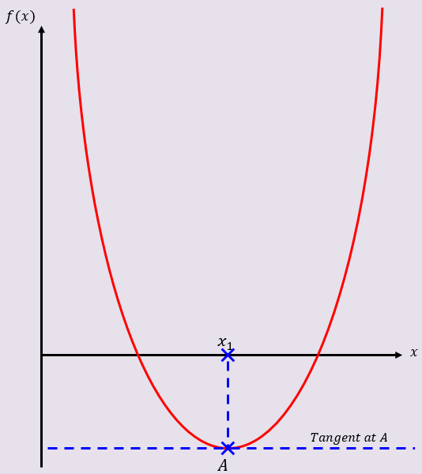

- The diagram shows part of the curve with equation $y=f(x)$, where $f\left(x\right)=x^{3}+2x^{2}-5x-4$.
The point $A$, with x-coordinate $p$, is a stationary point on the curve.
The equation f(x)=0 has a root, $α$, in the interval $1.8<α<1.9$.
- Explain why $x_{0}=p$ is not suitable to use as a first approximation to $α$ when applying the Newton-Raphson method to $f(x)$

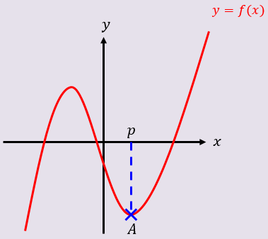

- Using $x_{0}=2$ as a first approximation to $α$, apply the Newton-Raphson method procedure twice to find a new approximation for $α$, to 3dp.

- By considering the change of sign in $f(x)$ over an appropriate interval, show that your answer to part b is accurate to 3 decimal places

