THE NEWTON-RAPHSON METHOD

The Newton- Raphson method can be used to find numerical solutions to equations of the form $f\left(x\right)=0$. You need to be able to differentiate $f\left(x\right)$ in order to use this method.
The Newton- Raphson formula is:
$$x_{n+1}=x_{n}-\frac{f\left(x_{n}\right)}{f^{'}\left(x_{n}\right)}$$

Example 1
Recall that in lesson 1 we saw that the function $f\left(x\right)=x-\cos\left(x\right)$ has a root, $α$, in the interval $0<α<1$.
Using $x_{0}=0.5$ as a first approximation to$α$, apply the Newton-Raphson procedure three times to find a better approximation to $α$ which, in this case, will be accurate to 7 decimal places.

To perform iterations quickly, do the following on your calculator:
[0.5] [=]
[ANS] – (ANS – cos(ANS))/(1 + sin(ANS))
Then press [=].

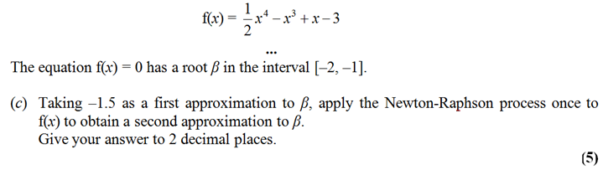
Example 2
Edexcel FP1 June 2013(R) Q3c

Edexcel FP1 Jan 2010 Q2c
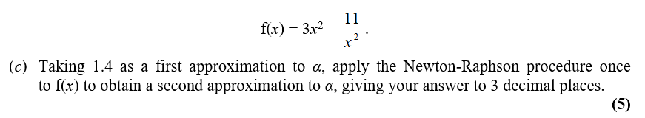
Example 3

When does Newton-Raphson fail?

$$x$$
$$y$$
$$x_{0}$$
tangent

$$x_{n+1}=x_{n}-\frac{f\left(x_{n}\right)}{f^{'}\left(x_{n}\right)}$$

If the starting value $x_{0}$ was the stationary point, then $f^{'}\left(x_{0}\right)=0$, resulting in a division by 0 in the above formula.
Graphically, it is because the tangent will never reach the $x$-axis.

$$x$$
$$y$$
$$y=\frac{x}{\sqrt{1+x^{2}}}$$
$$x_{0}$$
$$x_{1}$$
$$x_{2}$$
Newton-Raphson also suffers from the same drawbacks as solving by iteration, in that it is possible for the values of $x_{i}$ to diverge.
In this example, the $x_{i}$ oscillate either side of 0, but get gradually further away from $α=0$.

Exercise 10C Page 284

