10B Iterations

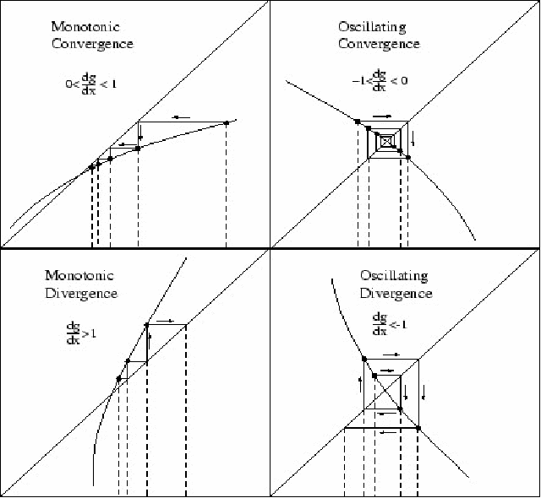
- Given that $f\left(x\right)=x^{2}-4x+1$
- Show that the equation $f\left(x\right)=0$ can be written as $x=4-\frac{1}{x}$, $x≠0$.

The equation $f(x)$ has a root, $α$, in the interval $3<x<4$.
- Use the iterative formula
$x_{n+1}=4-\frac{1}{x_{n}}$, with $x_{0}=3$ to find the value of $x_{1}$, $x_{2}$ and $x_{3}$.

$$f\left(x\right)=x^{3}-{3x}^{2}-2x+5$$
- Show that the equation $f\left(x\right)=0$ has a root in the interval $3<x<4$

- Use the iterative formula:
$$x_{n+1}=\sqrt{\frac{x_{n}^{3}-{2x}_{n}+5}{3}}$$
To calculate the values of $x_{1}$, $x_{2}$ and $x_{3}$, giving answers to 4 decimal places, when:
i) $x_{0}=1.5$ ii) $x_{0}=4$

