ITERATION
To solve $f\left(x\right)=0$ by an iterative method, rearrange into a form $x=g\left(x\right)$ and use the iterative formula $x_{n+1}=g\left(x_{n}\right)$
Example 1
Edexcel C3 Jan 2013
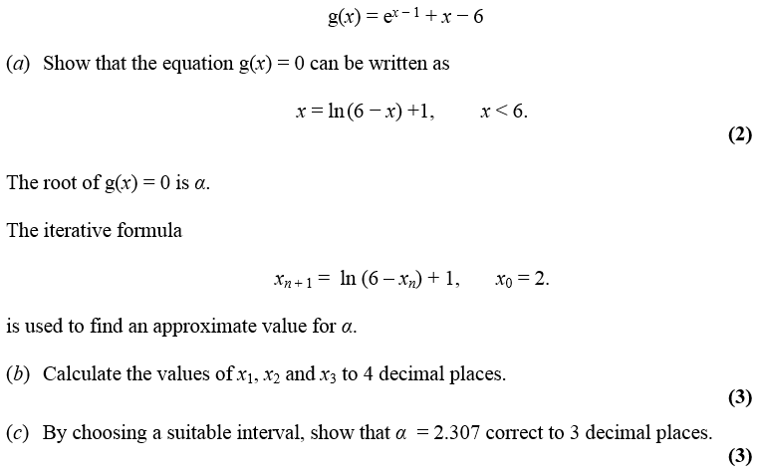

a)

b) $x_{1}$, $x_{2}$, $x_{3}$ represent successively better approximations of the root
Initially type $x_{0}$ (i.e. 2) onto your calculator.
Now just type: $\ln\left(6-ANS\right)+1$
And then press your $=$ key to get successive iterations.

c)

The starting value $x_{0}$matters.
- If there are a multiple roots, the iteration might converge to (i.e. approach) a different root.
- The iteration not converge to a root at all and diverges (i.e. approach infinity).

Example 2
$$f\left(x\right)=x^{3}-3x^{2}-2x+5$$
- Show that the equation $f\left(x\right)=0$ has a root in the interval $3<x<4$.
- Use the iterative formula $x_{n+1}=\sqrt{\frac{x_{n}^{3}-2x_{n}+5}{3}}$ to calculate the values of $x_{1}$, $x_{2}$ and $x_{3}$, giving your answers to 4 decimal places, and taking:
(i) $x_{0}=1.5$ (ii) $x_{0}=4$

Staircase and cobweb diagrams

Example 3
$$f\left(x\right)=x^{2}-8x+4$$
- Show that the root of the equation $f\left(x\right)=0$ can be written as $x=\sqrt{8x-4}$
- Using the iterative formula $x_{n+1}=\sqrt{8x_{n}-4}$, and starting with $x_{0}=1$, draw a staircase diagram, indicating $x_{0},x_{1}, x_{2}$ on your $x$-axis, as well as the root $α$.

Exercise 10B Page 280

