Upper 6 Chapter 10
Numerical Methods
Chapter Overview
1. Locating Roots
2. Iteration
3. The Newton-Raphson Method
4. Applications to Modelling

LOCATING ROOTS

Finding the root of a function $f\left(x\right)$ is to solve the equation $f\left(x\right)=0$

However, for some functions, the ‘exact’ root is complicated and difficult to calculate …

For example:
$$x^{3}+2x^{2}-3x+4=0$$
has the solution:
$$x=\frac{1}{3}\left(-2-\frac{13}{\sqrt[3]{89-6\sqrt{159}}}-\sqrt[3]{89-6\sqrt{159}}\right)$$

… or there is no ‘algebraic’ expression at all. (involving roots, logs, sin, cos, etc.)

For example:
$$x-\cos\left(x\right)=0$$

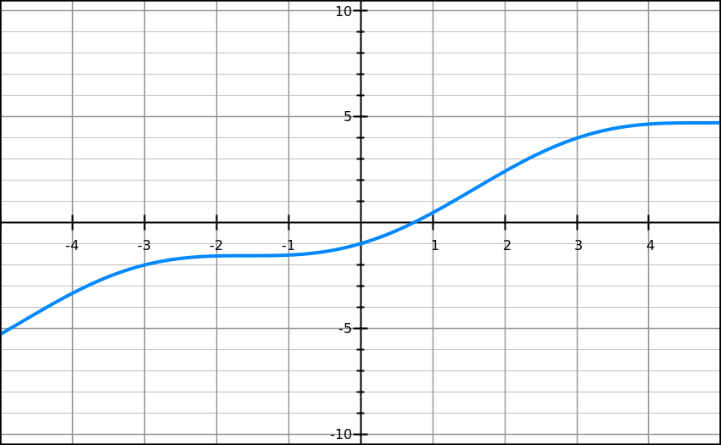

has a root here

To show that a root exists in a given interval, show that $f\left(x\right)$ changes sign

Example 1
Show that ${f\left(x\right)=e}^{x}+2x-3$ has a root between $x=0.5$ and $x=0.6$

STEP 1: Find $f\left(x\right)$ for the two values given in the question

STEP 2: Write a concluding statement referring to the change in sign and the fact that $f\left(x\right)$ is a continuous function

Note on functions that are NOT continuous:
If the function is not continuous, the sign change may be due to an asymptote rather than a root.
For example:
When $f\left(x\right)=\frac{1}{x}$, then $f\left(-1\right)=-1$ and $f\left(1\right)=1$.
However, although there is a sign change, a root does not exist between $x=-1$ and $x=1$

Note on continuous functions:
A continuous function could simply have an even number of roots in a given interval rather than no roots.
For example:
Here $f\left(a\right)$ is negative and $f\left(b\right)$ is also negative
However, although there are two roots, a sign change does not occur.
a
b

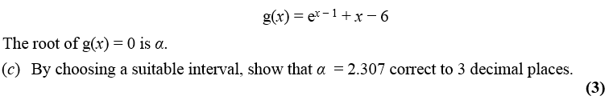
Example 2
Edexcel C3 Jan 2013

Example 3
(a) Using the same axes, sketch the graphs of $y=\ln{x}$ and $y=\frac{1}{x}$. Explain how your diagrams shows that the function $y=\ln\left(x\right)-\frac{1}{x}$ has only one root.
(b) Show that this root lies in the interval $1.7<x<1.8$
(c) Given that the root of $f\left(x\right)$ is $α$, show that $α=1.763$ correct to 3 decimal places.

Exercise 10A Page 276

