A Level Mathematics

Chapter 9 - Mechanics
Constant Acceleration
Chapter Overview
1. Displacement-Time Graphs
2. Velocity-Time Graphs
3. Constant Acceleration Formulae (SUVAT)
4. Vertical Motion Under Gravity

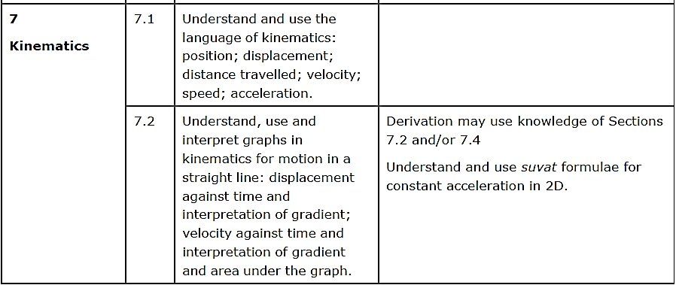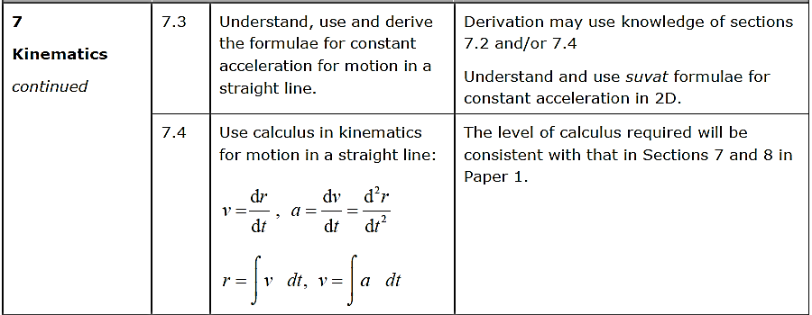

- Displacement-Time Graphs
Describe the motion of each object:

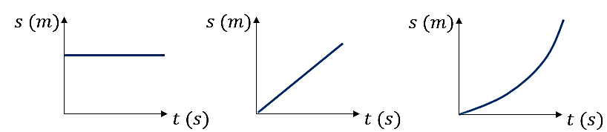

Velocity is the rate of change of displacement
(i.e. gradient of displacement-time graph)

Average Velocity = ___________________________

Average Speed = _________________________

Example (Exercise 9A Question 2)
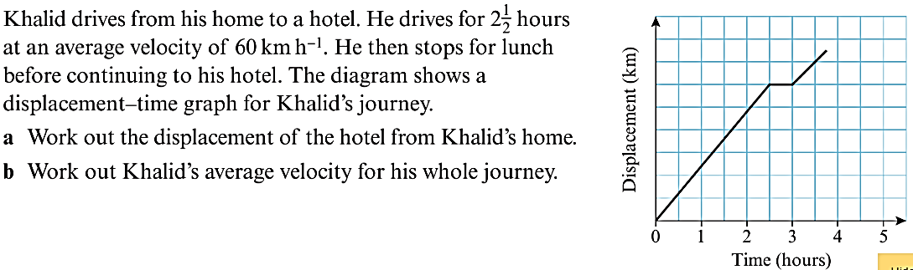

Exercise 9A Page 132
- Velocity-Time Graphs
Describe the motion of each object:

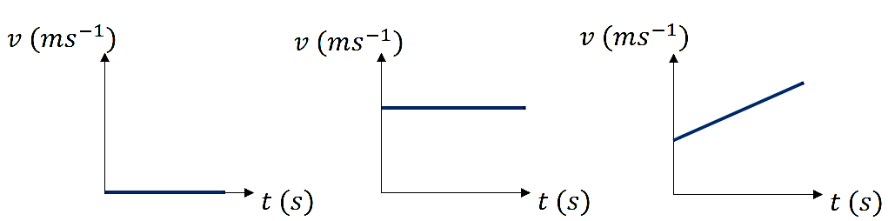

Acceleration the rate of change of velocity
(i.e. gradient of velocity-time graph)

The area under a velocity-time graph gives the distance travelled.

Example
The velocity-time graph shown is for a body which starts from rest, accelerates uniformly to a velocity of 8ms⁻¹ in 2 seconds, maintains that velocity for a further 5 seconds then decelerates uniformly to rest. The entire journey takes 11 seconds. Find:
a) The acceleration of the body during the initial part of the motion
b) The deceleration of the body during the final part of the motion
c) The total distance travelled by the body

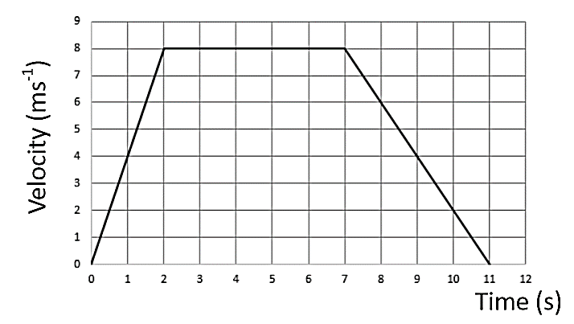

Algebraic Example
A particle moves along a straight line. The particle accelerates uniformly from rest to a velocity of 8 ms⁻¹ in $T$ seconds. The particle then travels at a constant velocity of 8 ms⁻¹ for $5T$ seconds. The particle then decelerates uniformly to rest in a further 40 s.
- Sketch a velocity-time graph to illustrate the motion of the particle.
Give then the total displacement of the particle is 600m.
(b) find the value of $T$.

Test Your Understanding (EdExcel M1 May 2013 Q5)
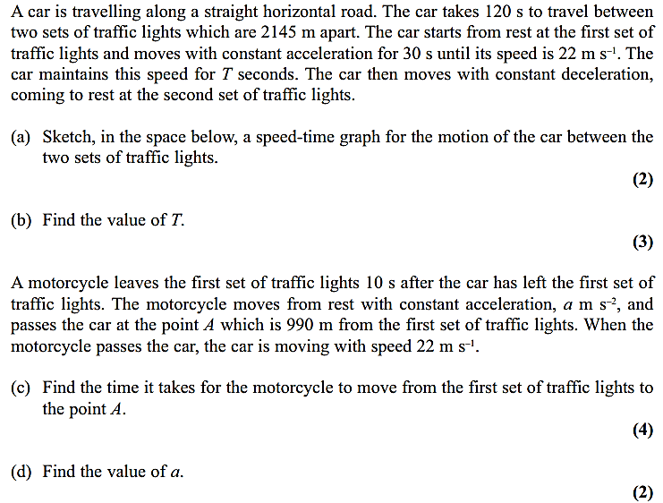

Exercise 9B Page 135

