U6 Pure Chapter 5
Radians

Course Structure
1: Converting between degrees and radians.
2: Find arc length and sector area (when using radians)
3: Solve trig equations in radians.
4: Small angle approximations

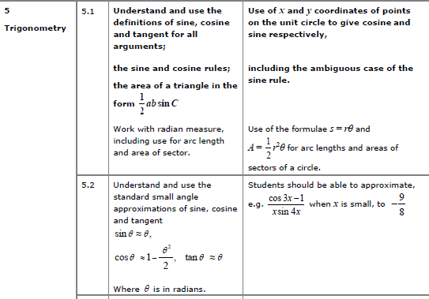

Radians

Converting between radians and degrees

$90°=$

$\frac{π}{3}=$

$45°=$

$\frac{π}{6}=$

$135°=$

$\frac{3}{2}π=$

$72°=$

$\frac{5π}{6}=$

It is useful to remember the standard angle conversions….

$45°=$

$60°=$

$270°=$

$120°=$
$30°=$

$135°=$

$90°=$

Graph Sketching with Radians

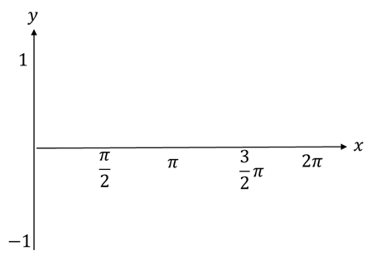
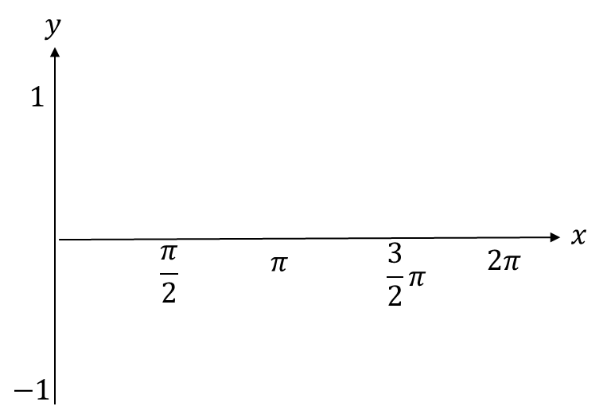

Test Your Understanding
Sketch the graph of $y=\cos\left(x+\frac{π}{2}\right)$ for $0≤x<2π$

Sin, cos, tan of angles in radians
Reminder of laws from Year 1:
- $\sin\left(x\right)=\sin\left(180-x\right)$
- $\cos\left(x\right)=\cos\left(360-x\right)$
- $sin,cos$ repeat every $360°$ but $tan$ every $180°$

In terms of radians:
- $\sin\left(x\right)=$
- $\cos\left(x\right)=$
- $sin,cos$ repeat every _______ but $tan$ every _____.

To find sin/cos/tan of a ‘common’ angle in radians without using a calculator, it is easiest to just convert to degrees first.

Examples
- $\cos\left(\frac{4π}{3}\right)=$

- $\sin\left(-\frac{7π}{6}\right)=$
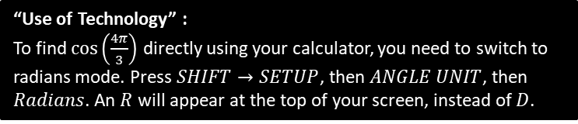

Page 116/118 Ex 5a/ 5b

Arc length
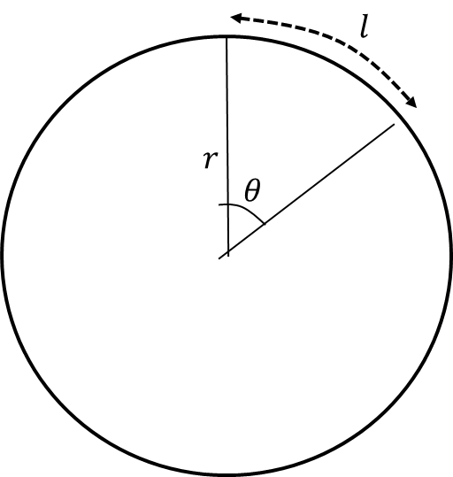
Arc length in degrees =

Arc length in radians =

Examples
- Find the length of the arc of a circle of radius 5.2 cm, given that the arc subtends an angle of 0.8 radians at the centre of the circle.

- An arc $AB$ of a circle with radius 7 cm and centre $O$ has a length of 2.45 cm. Find the angle $∠AOB$ subtended by the arc at the centre of the circle

- An arc $AB$ of a circle, with centre $O$ and radius $r$ cm, subtends an angle of $θ$ radians at $O$. The perimeter of the sector $AOB$ is $P$ cm. Express $r$ in terms of $P$ and $θ.$

- The border of a garden pond consists of a straight edge $AB$ of length 2.4m, and a curved part $C$, as shown in the diagram. The curve part is an arc of a circle, centre $O$ and radius 2m.
Find the length of $C$.

Test Your Understanding

Figure 1 shows the triangle $ABC$, with $AB=8 cm$, $AC=11 cm$ and $∠BAC=0.7$ radians. The arc $BD$, where $D$ lies on $AC$, is an arc of a circle with centre $A$ and radius 8 cm. The region $R$, shown shaded in Figure 1, is bounded by the straight lines $BC$ and $CD$ and the arc $BD$.
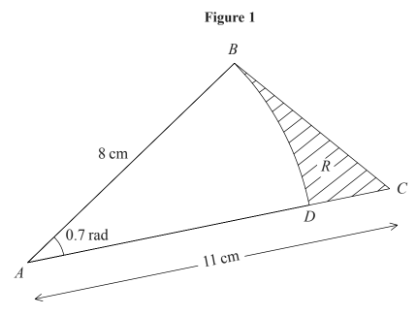
Find
(a) The length of the arc $BD$.
(b) The perimeter of $R$, giving your answer to 3 significant figures.

Ex 5C Page 120
Sector Area

Area using Degrees =

Area using Radians =

Segment Area
Recall that the area of a triangle is $\frac{1}{2}ab\sin{C}$ where $C$ is the ‘included angle’ (i.e. between $a$ and $b$)

Area using radians:

Examples
- In the diagram, the area of the minor sector $AOB$ is 28.9 cm². Given that $∠AOB=0.8$ radians, calculate the value of $r$.

- A plot of land is in the shape of a sector of a circle of radius 55 m. The length of fencing that is erected along the edge of the plot to enclose the land is 176 m. Calculate the area of the plot of land.

- In the diagram above, $OAB$ is a sector of a circle, radius 4m. The chord $AB$ is 5m long. Find the area of the shaded segment.

- In the diagram, $AB$ is the diameter of a circle of radius $r$cm, and $∠BOC=θ$ radians. Given that the area of $ΔAOC$ is three times that of the shaded segment, show that
$3θ-4\sin{θ}=0$.

Test Your Understanding

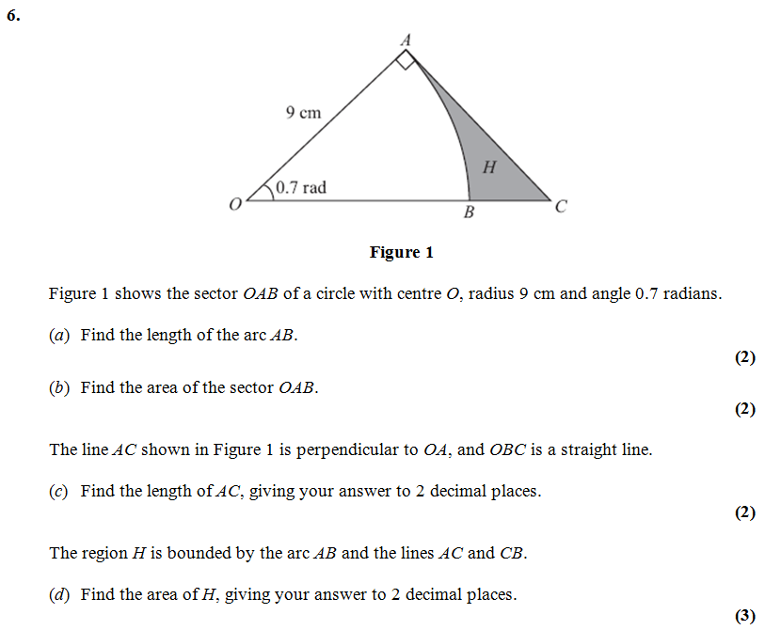

Extension
[MAT 2012 1J]
If two chords $QP$ and $RP$ on a circle of radius 1 meet in an angle $θ$ at $P$, for example as drawn in the diagram on the left, then find the largest possible area of the shaded region $RPQ$, giving your answer in terms of $θ$.
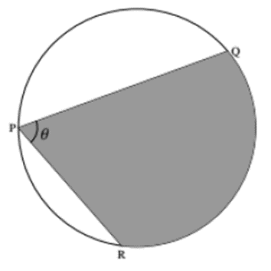

Ex 5D Page 125 - 128

Solving Trigonometric Equations

Solving trigonometric equations is virtually the same as you did in Year 1, except:

- Your calculator needs to be in radians mode.
- We use $π-$ instead of $180°-$, and so on.

Remember
- $\sin\left(x\right)=\sin\left(π-x\right)$
- $\cos\left(x\right)=\cos\left(2π-x\right)$
- $sin,cos$ repeat every $2π$ but $tan$ every $π$

Example
Solve the equation
$\sin{3θ}=\frac{\sqrt{3}}{2}$ in the interval $0≤θ≤2π$.

Test Your Understanding
[Jan 07 Q6]
Find all the solutions, in the interval 0 ≤ x < 2π, of the equation
2 cos² x + 1 = 5 sin x, giving each solution in terms of π. (6)

Extension
[MAT 2010 1C] In the range $0≤x≤2π$, the equation $\sin^{2}{x}+3\sin{x}\cos{x}+2\cos^{2}{x}=0$ has how many solutions?

Ex 5E Pg 131

Small Angle Approximations

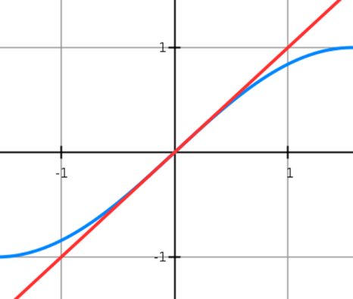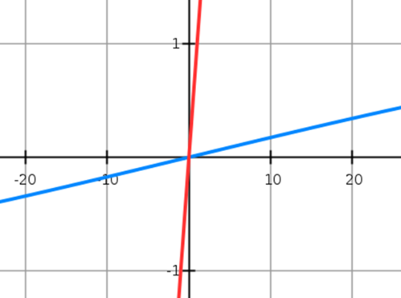

Example
When $θ$ is small, find the approximate value of:
- $\frac{\sin{2θ}+\tan{θ}}{2θ}$

- $\frac{\cos{4θ}-1}{θ\sin{2θ}}$

Example
a) Show that, when $θ$ is small,
$$\sin{5θ}+\tan{2θ}-\cos{2θ}≈2θ^{2}+7θ-1$$
b) Hence state the approximate value of
$\sin{5θ}+\tan{2θ}-\cos{2θ}$ for small values of $θ$.
Ex 5F Pg 134

