A Level Mathematics

Chapter 9 - Mechanics
Constant Acceleration
Chapter Overview
1. Displacement-Time Graphs
2. Velocity-Time Graphs
3. Constant Acceleration Formulae (SUVAT)
4. Vertical Motion Under Gravity

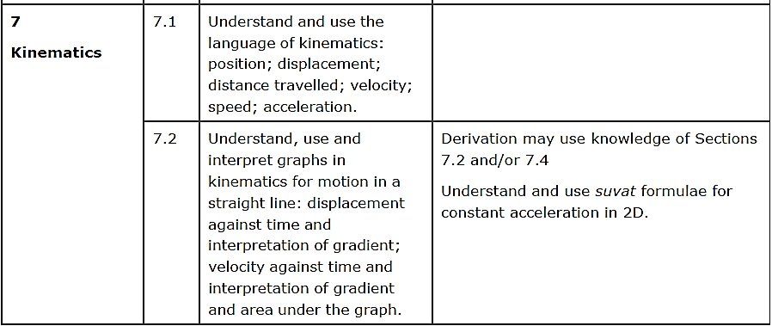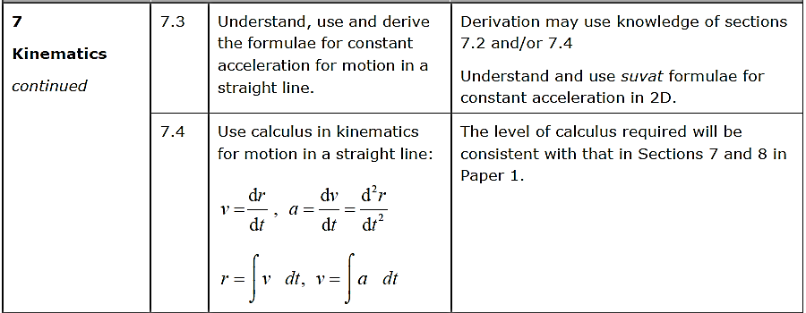

- Displacement-Time Graphs
Describe the motion of each object:

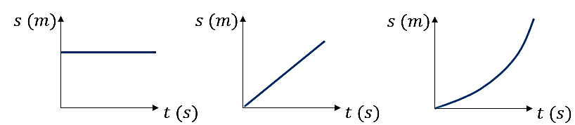

Velocity is the rate of change of displacement
(i.e. gradient of displacement-time graph)

Average Velocity = ___________________________

Average Speed = _________________________

Example (Exercise 9A Question 2)
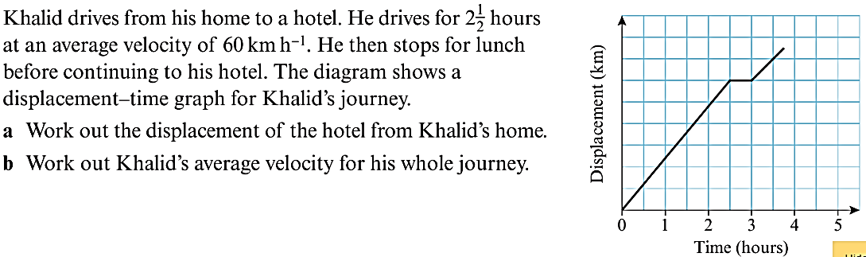

Exercise 9A Page 132
- Velocity-Time Graphs
Describe the motion of each object:

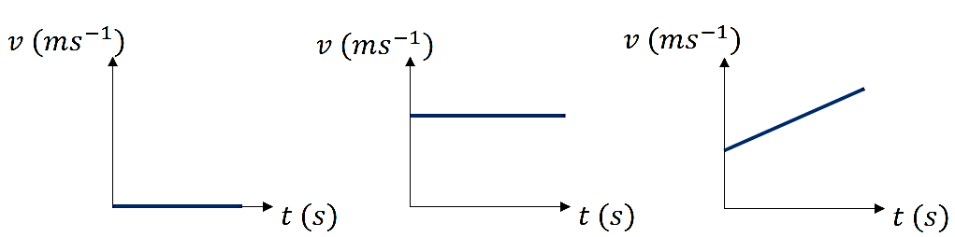

Acceleration the rate of change of velocity
(i.e. gradient of velocity-time graph)

The area under a velocity-time graph gives the distance travelled.

Example
The velocity-time graph shown is for a body which starts from rest, accelerates uniformly to a velocity of 8ms⁻¹ in 2 seconds, maintains that velocity for a further 5 seconds then decelerates uniformly to rest. The entire journey takes 11 seconds. Find:
a) The acceleration of the body during the initial part of the motion
b) The deceleration of the body during the final part of the motion
c) The total distance travelled by the body

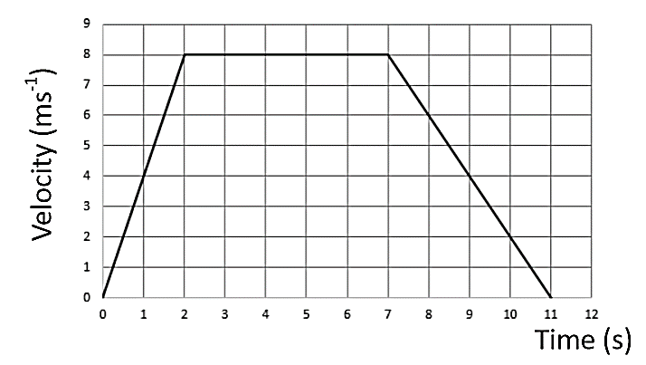

Algebraic Example
A particle moves along a straight line. The particle accelerates uniformly from rest to a velocity of 8 ms⁻¹ in $T$ seconds. The particle then travels at a constant velocity of 8 ms⁻¹ for $5T$ seconds. The particle then decelerates uniformly to rest in a further 40 s.
- Sketch a velocity-time graph to illustrate the motion of the particle.
Give then the total displacement of the particle is 600m.
(b) find the value of $T$.

Test Your Understanding (EdExcel M1 May 2013 Q5)
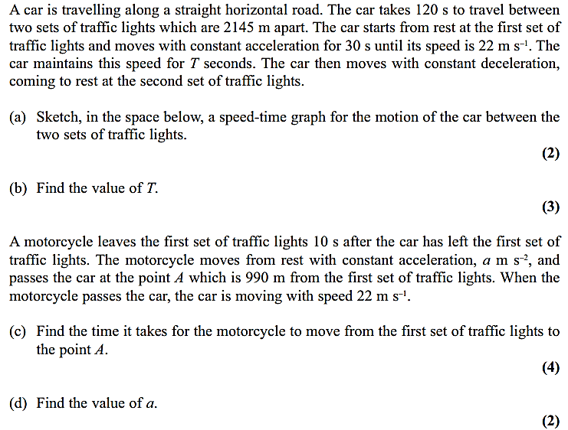

Exercise 9B Page 135
3-4. Constant Acceleration Formulae (SUVAT Equations)
These formulae are used to solve problems where the object is moving in a straight line with constant acceleration for a specific period of time. You should memorise these and know how to derive them.

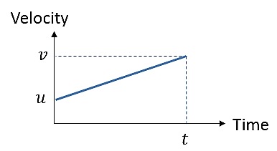

$$Acceleration=\frac{change in velocity}{time}$$

$v=$

(Equation 1)
For uniform acceleration, the average velocity is the average of v and u. Using the area of the graph (which we know gives distance):

$$s=$$

(Equation 2)
Eliminating v - sub for v from equation 1 into equation 2:

$$s=$$

(Equation 3)
Eliminating t - sub for t from equation 1 into equation 2:

$$v^{2}=$$

(Equation 4)

Eliminating u – sub for u from equation 1 into equation 2:

$$s=$$

(Equation 5)

- Work out what you know
- Work out what you need
- Choose the appropriate equation
- Diagrams help!
- Work out which direction will be positive
- Check that your units are consistent

Example
A stone slides in a straight line across a horizontal sheet of ice. It passes a point, A with velocity 14ms⁻¹ and a point, B 2.5 seconds later. Assuming the deceleration is uniform and that AB = 30m, find:
a) The deceleration
b) The velocity at B
c) How long after passing A the stone comes to rest

Example – Deceleration Leading to a Change in Direction
A particle travels with uniform deceleration 2ms⁻² in a horizontal line. The points A and B lie on the line and AB = 32m. At time t = 0, the particle passes through A with velocity 12ms⁻¹ in the direction AB. Find:
a) The values of t when the particle is at B
b) The velocity of the particle for each of these values of t.

Test Your Understanding (EdExcel M1 May 2013 Q4)
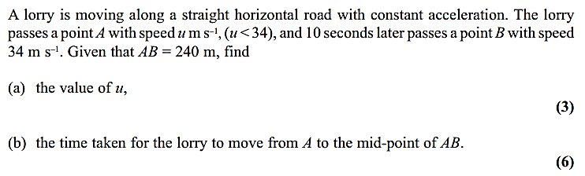
Exercise 9C Page 140
Exercise 9D Page 145

5. Vertical Motion Under Gravity

The downwards acceleration under gravity is $g=9.8$ms⁻².
ALWAYS state the positive direction in your calculations.
Quote final answers to 2 or 3 s.f. – you may be penalised if you quote more.

Example
A ball is thrown vertically upwards with a velocity of 14.7ms⁻¹ from a platform 19.6m above the ground. Find:
a) The time taken for the ball to reach the ground
b) The velocity of the ball when it hits the ground

Example
A ball is projected vertically upwards from ground level at a speed of 20 ms⁻¹.
Determine the amount of time the ball is at least 10m above ground level.

Example – When Two Particles are in Motion
Two stones are thrown from the same point at the same time - one vertically upwards with speed 30ms⁻¹ and one vertically downwards at 30ms⁻¹. Find how far apart the stones are after 3 seconds.

Test Your Understanding (EdExcel M1 May 2013 (R) Q4)
Exercise 9E Page 151
Mixed Exercise 9 Page 152
