8A Constructing Models

- The motion of a basketball as it leaves a player’s hand and passes through the net can be modelled using the equation $h=2+1.1x-0.1x^{2}$, where h is the height of the ball above the ground, and x is the horizontal distance travelled (both in metres).

- Find the height of the basketball;

- When it is first released

- After it has travelled a horizontal distance of 0.5m

- Use the model to predict the height of the basketball when it is at a horizontal distance of 15m from the player

- Comment on the validity of this prediction

8B Modellings Assumptions

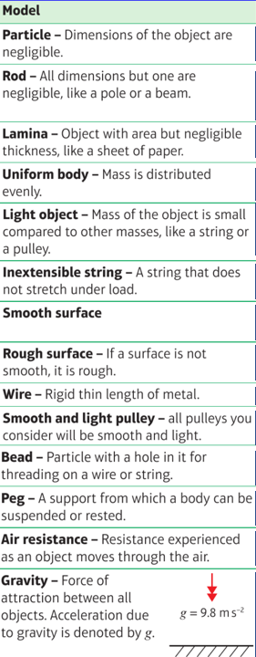

- A mass is attached to a length of string which is fixed to the ceiling. The mass is drawn to the side with the string taut and allowed to swing.
State the effect of the following assumptions on any calculations to be made:
- The string is light and inextensible

- The mass is modelled as a particle

8C SI Units

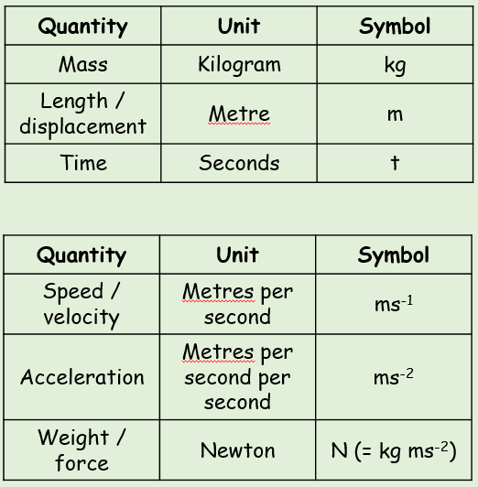

The Normal Reaction

Frictional Force

Tension

Thrust

Resistance

Gravity

Weight

Buoyancy

- Write the following quantities in SI units:
- 4km

- 0.32g

- 5.1 x 10⁶ kmh⁻¹

- The plane below is mid-flight. State the names of the labelled forces acting on it.

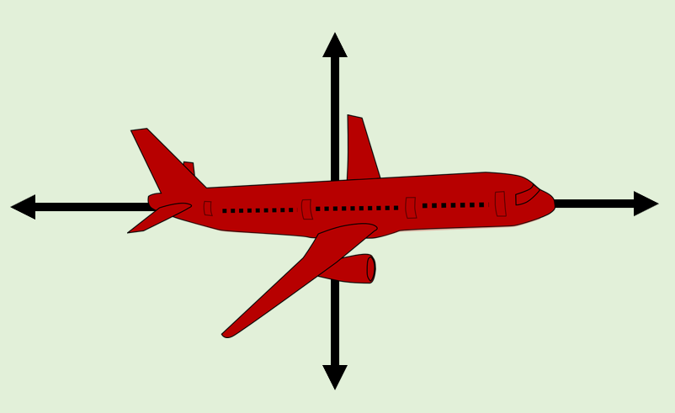

8D Vectors

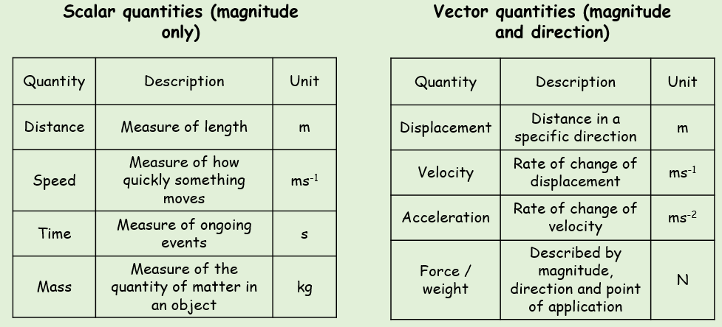

- Fully describe the motion of the particles below:
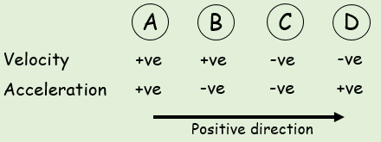

2D Notation

- The velocity of a particle is given by $v=3i+5j ms^{-1}$
Find:
- The speed of the particle

- The angle the direction of motion of the particle makes with the unit vector i.

- A man walks from A to B and then from B to C. His displacement from A to B is 6i + 4j km. His displacement from B to C is 5i – 12j km.
- What is the magnitude of the displacement from A to C?

- What is the total distance the man walked in getting from A to C?

