A Level Mathematics

Chapter 8 - Mechanics
Modelling in Mechanics

Chapter Overview
1. Constructing a Model
2. Modelling Assumptions
3. Quantities and Units
4. Working with Vectors

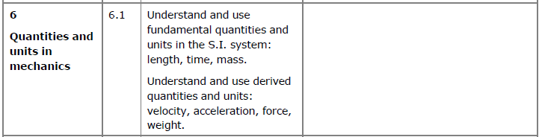

What is Mechanics?
Broadly speaking, mechanics covers motion, forces and how the two inter-relate with each other.
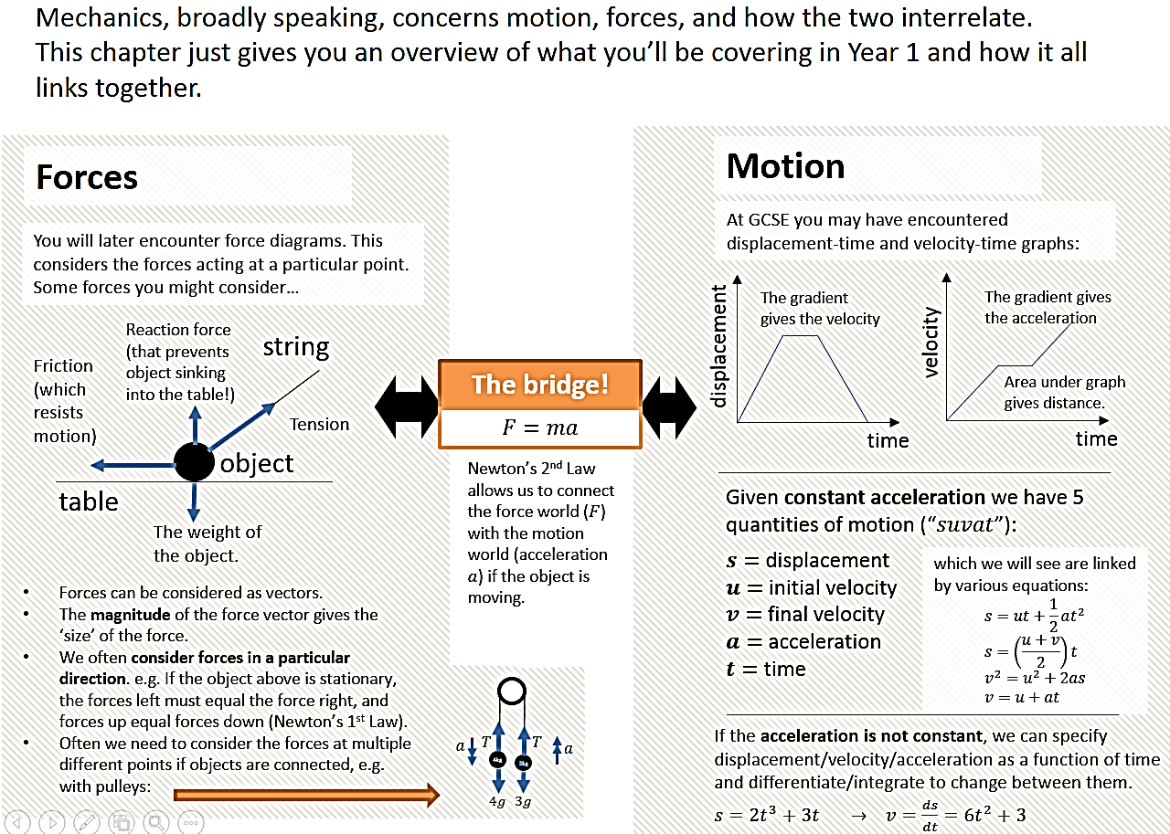
- Constructing a Model
Why use a mathematical model?

The solution to a mathematical model needs to be interpreted in the context of the original problem. You may need to refine the model and reconsider your original assumptions.

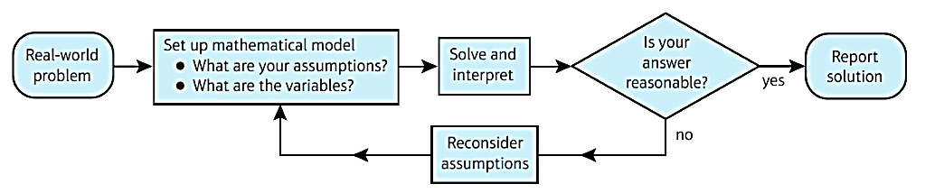
Example (Textbook)
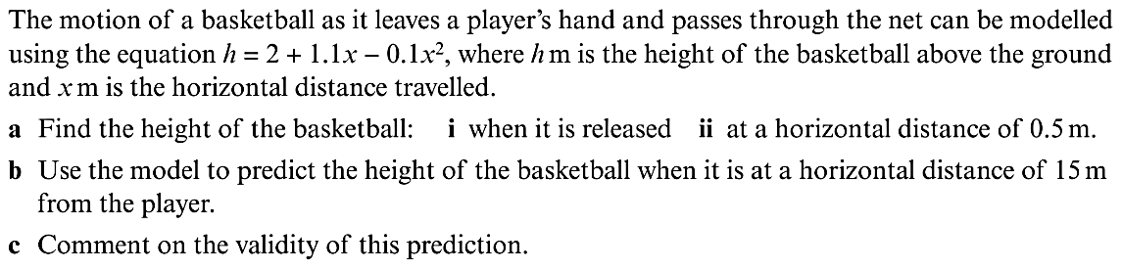

Exercise 8A Page 119
- Modelling Assumptions
We make modelling assumptions to simplify a problem and solve it using known mathematical techniques. You must be able to understand how these assumptions will affect calculations versus the real-life situation.

A full list of modelling assumptions is on p121 of the textbook. The most common are shown below.

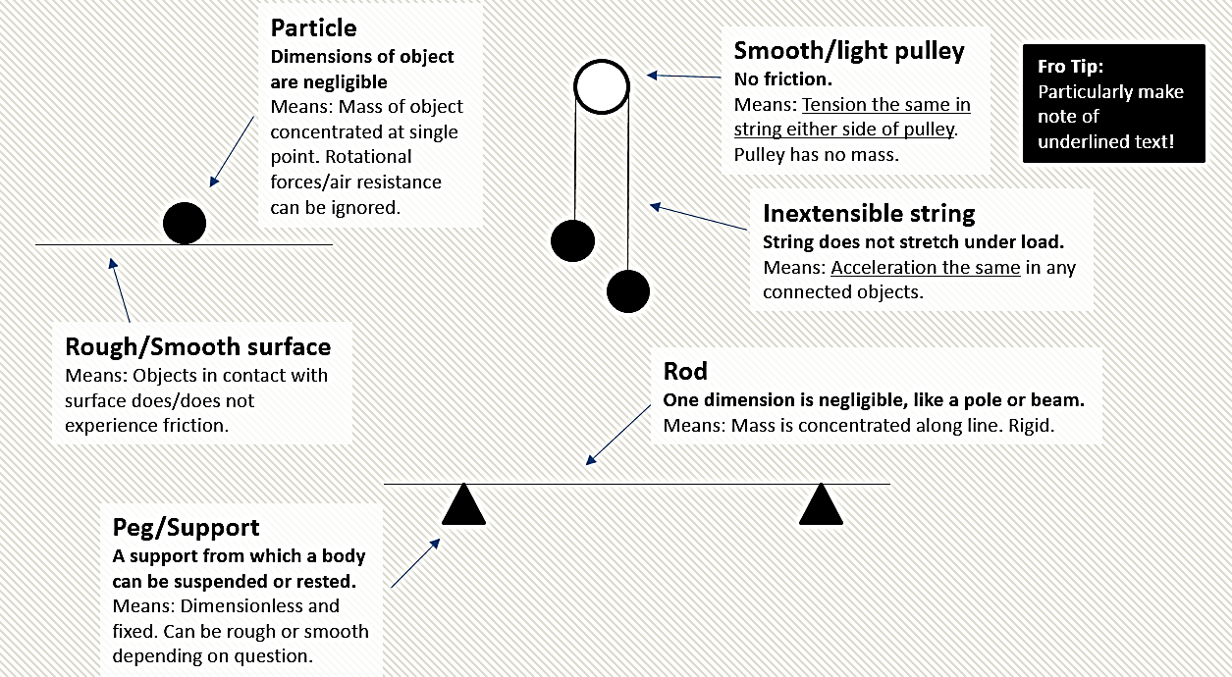

Example (Exercise 8B Question 2)
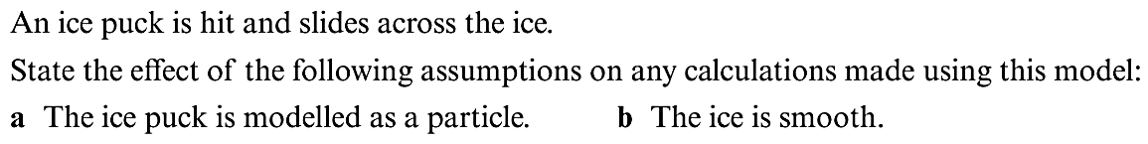

Exercise 8B Page 122
- Quantities and Units
The SI units are a standard system of units, used internationally (“Système International d’unités”). These are the base ones you will use:

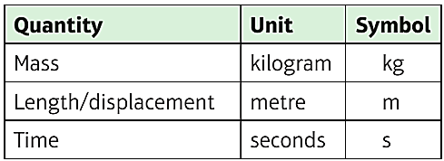
These derived units are compound units built from the base units.
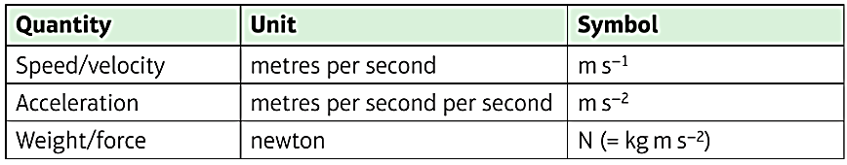
Can you convert 2.48 x 10⁵ kmh⁻¹ into SI units?

Types of Force and Force Diagrams
You will encounter a variety of forces in mechanics. It is ALWAYS helpful to draw a force diagram and make sure that you have included all forces acting on a body.

- Weight (always vertically downwards)
- Normal Reaction (always perpendicular to the surface of contact)
- Friction (only if the plane is ROUGH, always opposes motion)
- Tension (in a string – PULL force)
- Thrust/compression (e.g. in a rod or engine – PUSH force)
- Resistance (e.g. particle travelling through a liquid, always opposes direction of motion)
- Buoyancy (e.g. boat floating in water, always vertically upwards)

Force diagrams can be found on page 123 of the textbook.
Exercise 8C Page 124
- Working with Vectors
In Mechanics you will often need to convert to/from the scalar form of a quantity and the vector form.

SCALAR:

VECTOR:

Examples of scalars and vectors:
Scalar | Vector

NB: 1-dimensional vectors are still different from scalars. Consider the displacement on a 1-dimensional line in a particular direction. If we’d gone backwards 3 units…

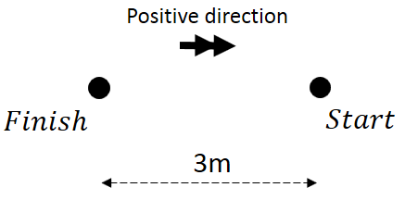
What is the distance travelled?

What is the displacement of the particle?

Vector Notation
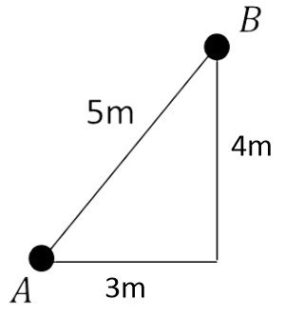

Column Notation i-j Notation
(i and j are unit vectors of length 1)

Adding and Subtracting Vectors
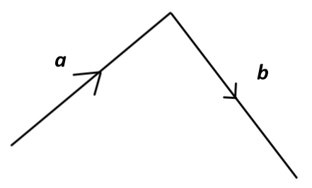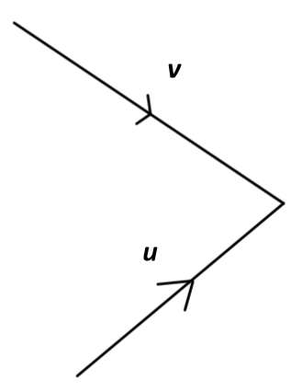

Two vectors are equal if they have the same magnitude and direction.

Two vectors are parallel if they have the same direction but different magnitudes.

Converting Between Vectors and Scalars
To convert to vector form, just use basic trigonometry to find the 𝑥 -change and 𝑦 -change.

Scalar (Distance) Vector (Displacement)

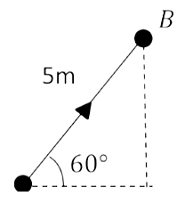

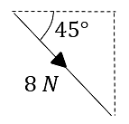

To convert scalar form, just find the magnitude of the vector using Pythagoras.

Vector (Velocity) Scalar (Speed)

$$\left(\begin{matrix}5 \\ -12\end{matrix}\right) ms^{-1}$$

Further Examples

Test Your Understanding
A woman walks from A to B and then from B to C.
Her displacement from A to B is 6i + 4j m.
Her displacement from B to C is 5i - 12j m.

a) What is the magnitude of the displacement from A to C?
b) What is the total distance the woman has walked in getting from A to C?
Exercise 8D Page 127
Mixed Exercise 8 Page 128

