A Level Mathematics

Chapter 6 - Statistics
Statistical distributions

Chapter Overview
- General probability distributions
- Binomial distribution
- Cumulative binomial probabilities

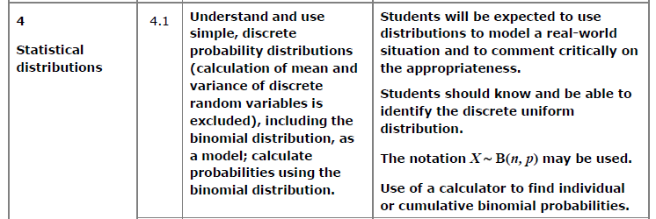

Probability Distributions

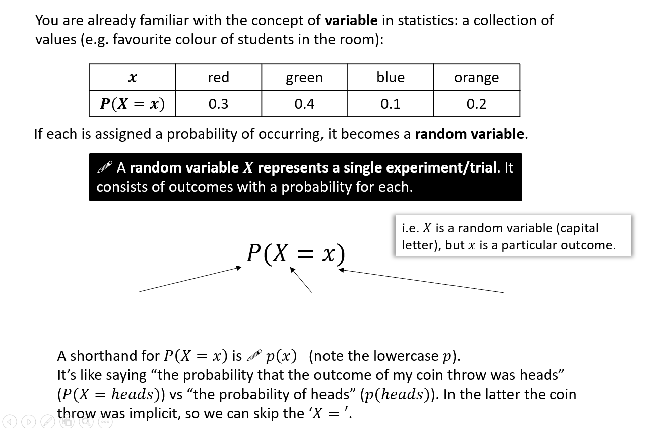

Probability Distributions vs Probability Functions
There are two ways to write the mapping from outcomes to probabilities:

- As a function

- As a table
$$x$$ | 1 | 2 | 3 | 4
$$p(x)$$

Example
The random variable $X$ represents the number of heads when three coins are tossed.
Sample Space

Distribution as a table
$$x$$
$$p(X=x)$$

Distribution as a function

Example
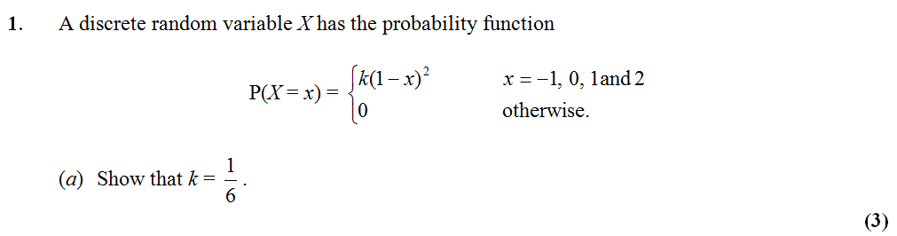
$$x$$
$$p(X=x)$$
Remember:

Probability of a Range
We may need to consider the probability of a range of solutions.
Example: Find the given probabilities for this probability distribution
$$x$$ | $$2$$ | $$3$$ | $$4$$ | $$5$$
$$p(x)$$ | $$0.1$$ | $$0.3$$ | $$0.2$$ | $$0.4$$

$$a) P\left(X>3\right)$$

b) $P\left(2≤X<4\right)$

c) $P\left(2X+1≥6\right)$
We can also represent a probability distribution graphically:
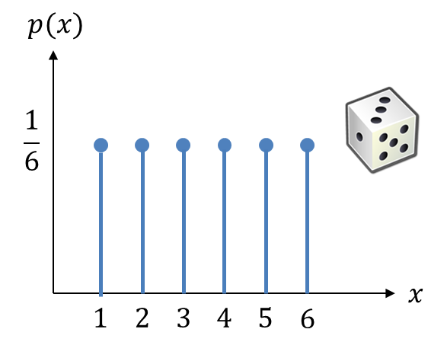
- The throw of a die is an example of a discrete uniform distribution because the probability of each outcome is the same.

- $p(x)$ for discrete random variables is known as a probability mass function, because the probability of each outcome represents an actual ‘amount’ (i.e. mass) of probability.

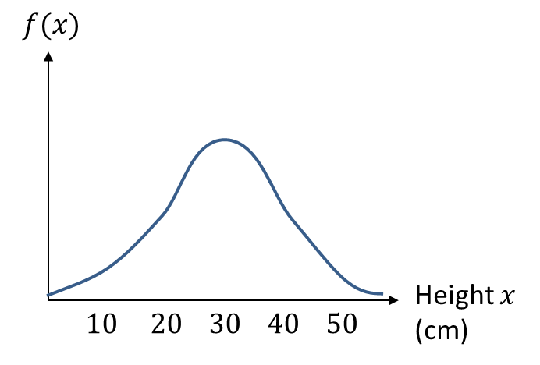
- We can also have probability distributions for continuous variables, e.g. height

- However, the probability that something has a height of say exactly 30cm, is infinitely small (effectively 0).

$p(x)$ (written $f(x)$) for continuous random variables is known as a probability density function. $p(30)$ wouldn’t give us the probability of being 30cm tall, but the amount of probability per unit height, i.e. the density. This is similar to histograms where frequency density is the “frequency per unit value”. Just as an area in a histogram would then give a frequency, and area under a probability density graph would give a probability (mass).
You will encounter the Normal Distribution in Year 2, which is an example of a continuous probability distribution.

Textbook Exercise 6A Pg 86
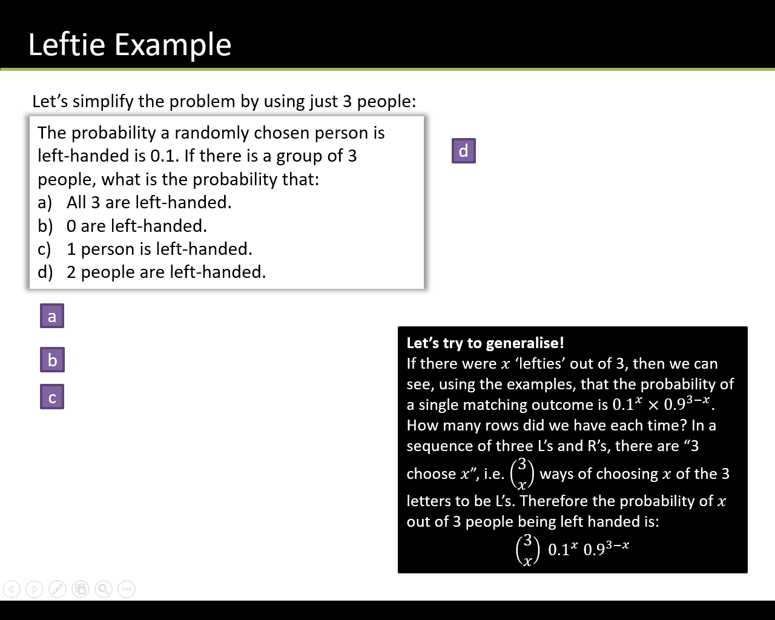

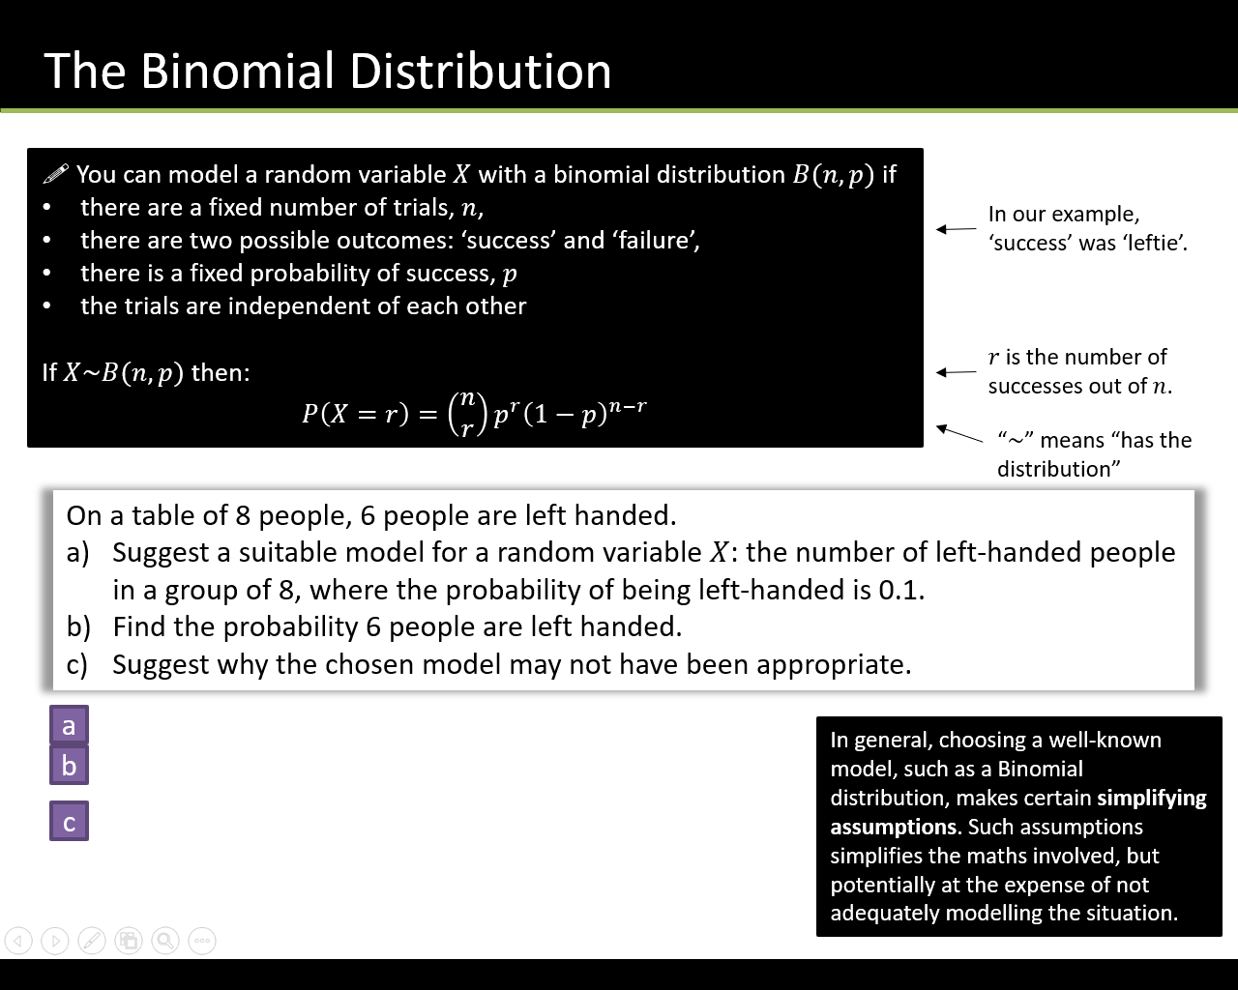

The random variable $X\sim B\left(12,\frac{1}{6}\right)$. Find:
- $P\left(X=2\right)$
- $P\left(X=9\right)$
- $P\left(X≤1\right)$

A company claims that a quarter of the bolts sent to them are faulty. To test this claim the number of faulty bolts in a random sample of 50 is recorded.
(a) Give two reasons why a binomial distribution may be a suitable model for the number of faulty bolts in the sample. (2)

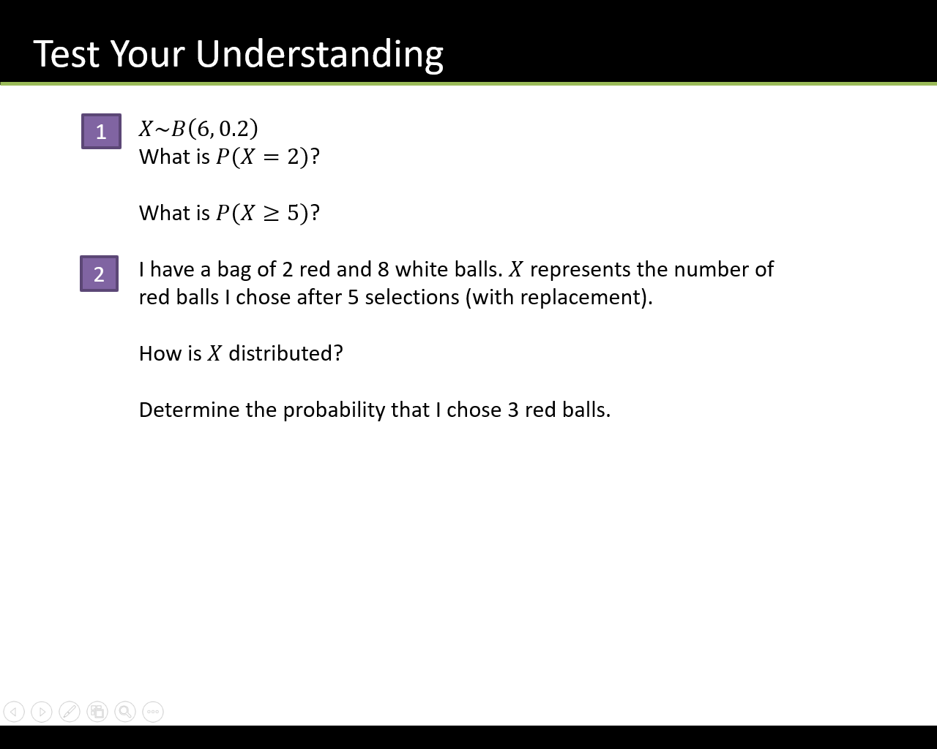

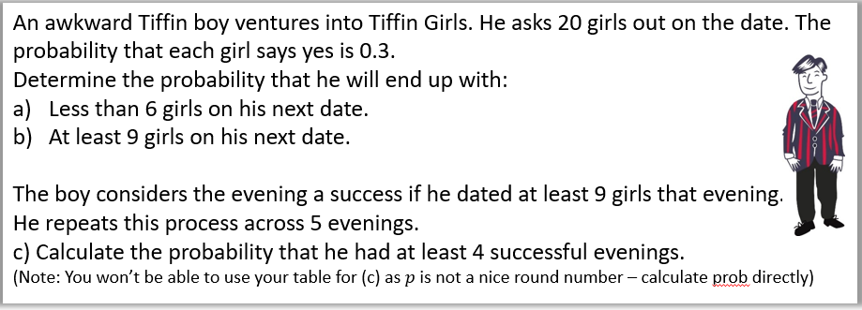

Textbook Exercise 6B Pg 90

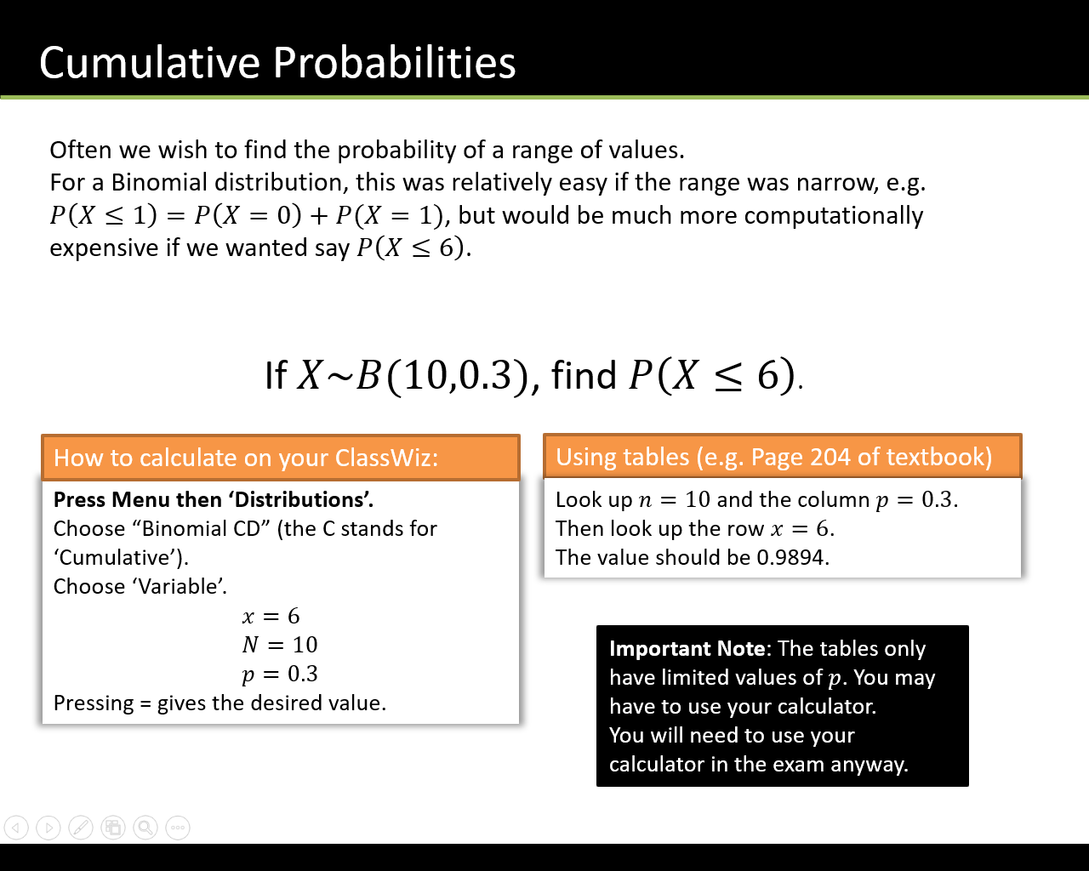

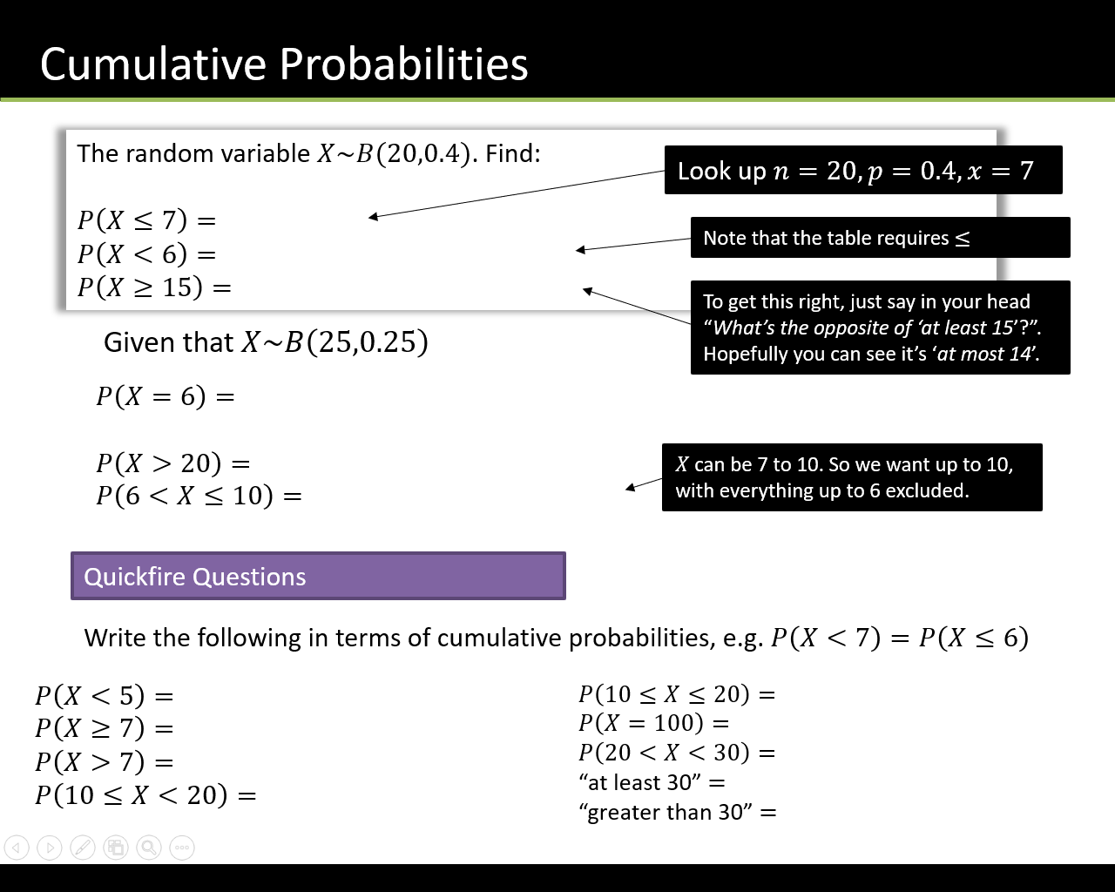

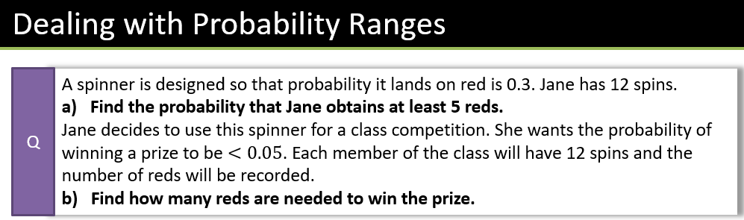

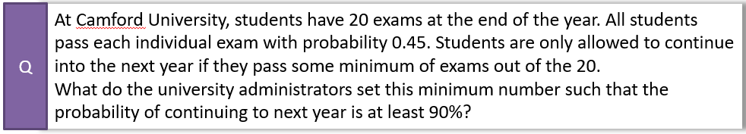

Textbook Exercise 6C Pg 93

