Lower 6 Chapter 14
Exponentials and logarithms

Chapter Overview
- Sketch exponential graphs.
- Use and interpret models that use exponential functions.
- Be able to differentiate $e^{kx}$.
- Understand the log function and use laws of logs.
- Use logarithms to estimate values of constants in non-linear models.

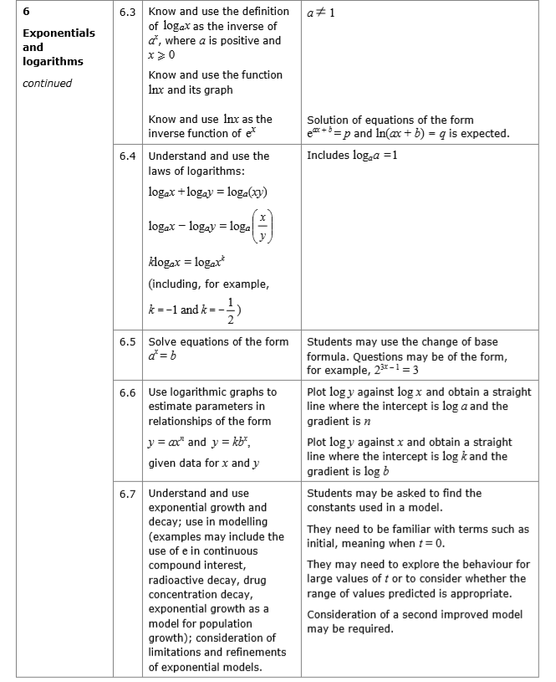
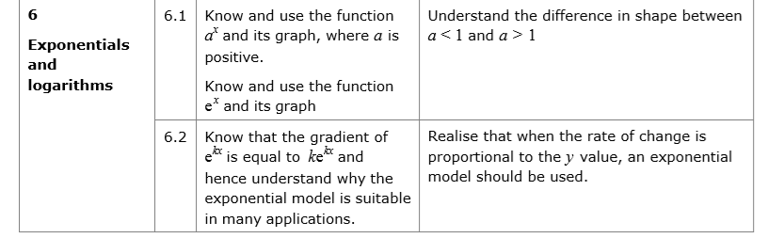

Contrasting exponential graphs
On the same axes sketch $y=3^{x}, y=2^{x}$, $y={1.5}^{x}$

On the same axes sketch $y=2^{x}$ and $y={\left(\frac{1}{2}\right)}^{x}$

Graph Transformations
Sketch $y=2^{x+3}$

Exercise 14A Pg 313-314

AD Page 11
Differentiating $y=ae^{kx}$
If $y=e^{kx}$, where $k$ is a constant, then $\frac{dy}{dx}=ke^{kx}$

Different $e^{5x}$ with respect to $x$.

Different $e^{-x}$ with respect to $x$.

Different $4e^{3x}$ with respect to $x$.

More Graph Transformations
Sketch $y=e^{3x}$

Sketch $y=5e^{-x}$

Sketch $y=2+e^{\frac{1}{3}x}$

Sketch $y=e^{-2x}-1$

Exercise 14B Pg 316-317

AD Page 11
Exponential Modelling
There are two key features of exponential functions which make them suitable for population growth:
- $a^{x}$ gets $a$ times bigger each time $x$ increases by 1. (Because $a^{x+1}=a×a^{x}$)
With population growth, we typically have a fixed percentage increase each year. So suppose the growth was 10% a year, and we used the equivalent decimal multiplier, 1.1, as $a$. Then ${1.1}^{t}$, where $t$ is the number of years, would get 1.1 times bigger each year.
- The rate of increase is proportional to the size of the population at a given moment.
This makes sense: The 10% increase of a population will be twice as large if the population itself is twice as large.

Example
[Textbook] The density of a pesticide in a given section of field, $P$ mg/m², can be modelled by the equation $P=160e^{-0.006t}$
where $t$ is the time in days since the pesticide was first applied.
a. Use this model to estimate the density of pesticide after 15 days.
b. Interpret the meaning of the value 160 in this model.
c. Show that $\frac{dP}{dt}=kP$, where $k$ is a constant, and state the value of $k$.
d. Interpret the significance of the sign of your answer in part (c).
e. Sketch the graph of $P$ against $t$.

Exercise 14C Pg 318-319

AD Page 11
Logarithms
$\log_{a}{n}$ (“said log base $a$ of $n$”) is equivalent to $a^{x}=n$.
The log function outputs the missing power.

Examples
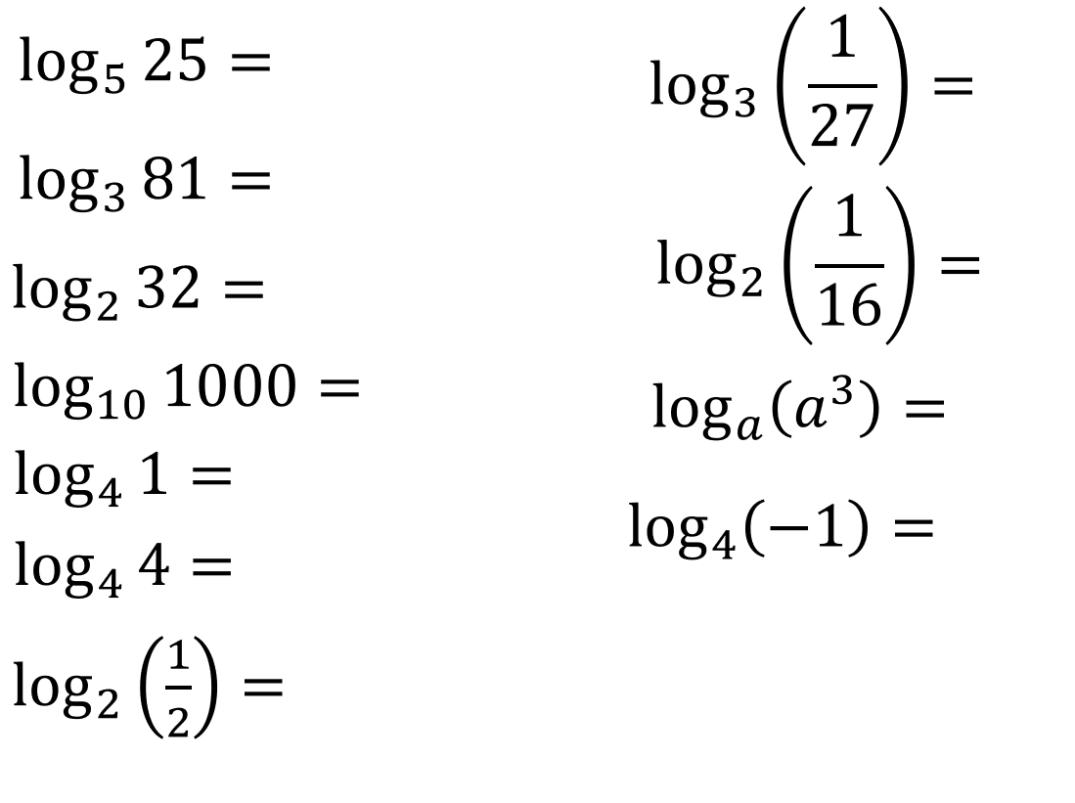
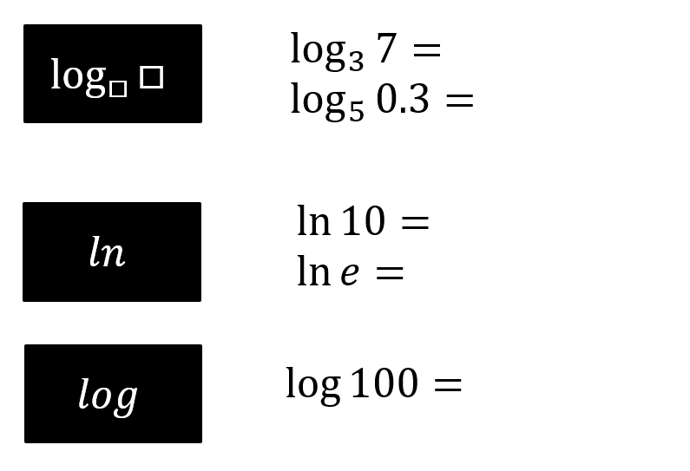
With your calculator…

Exercise 14D Pg 320-321

AD Page 11
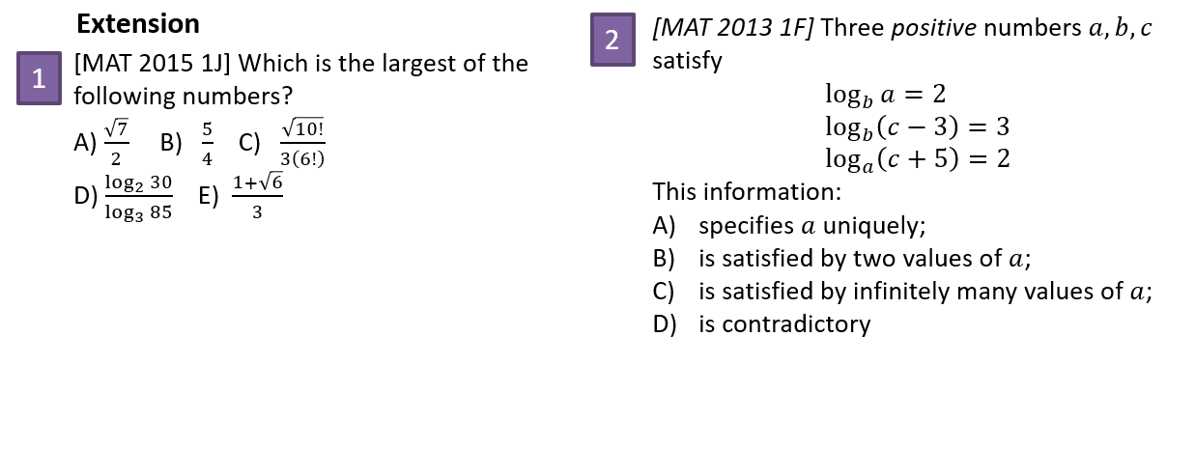

Laws of logs
Three main laws:
$$\log_{a}{x}+\log_{a}{y}=\log_{a}{xy}$$
$$\log_{a}{x}-\log_{a}{y}=\log_{a}\left(\frac{x}{y}\right)$$
$$\log_{a}\left(x^{k}\right)=k\log_{a}{x}$$
Special cases:
$$\log_{a}{a}=1 \left(a>0, a≠1\right)$$
$$\log_{a}{1}=0 \left(a>0, a≠1\right)$$
$$\log\left(\frac{1}{x}\right)=\log\left(x^{-1}\right)=-\log\left(x\right)$$
Not in syllabus (but in MAT/PAT):
$$\log_{a}{b}=\frac{\log_{c}{b}}{\log_{c}{a}}$$

Examples
Write as a single logarithm:
- $\log_{3}{6}+\log_{3}{7}$

- $\log_{2}{15}-\log_{2}{3}$

- $2\log_{5}{3}+3\log_{5}{2}$

- $\log_{10}{3}-4\log_{10}\left(\frac{1}{2}\right)$

Write in terms of $\log_{a}{x}$, $\log_{a}{y}$ and $\log_{a}{z}$
- $\log_{a}{(x^{2}yz^{3}})$

- $\log_{a}\left(\frac{x}{y^{3}}\right)$
- $\log_{a}\left(\frac{x\sqrt{y}}{z}\right)$

- $\log_{a}\left(\frac{x}{a^{4}}\right)$

Solving equations with logs
Solve the equation $\log_{10}{4}+2\log_{10}{x}=2$

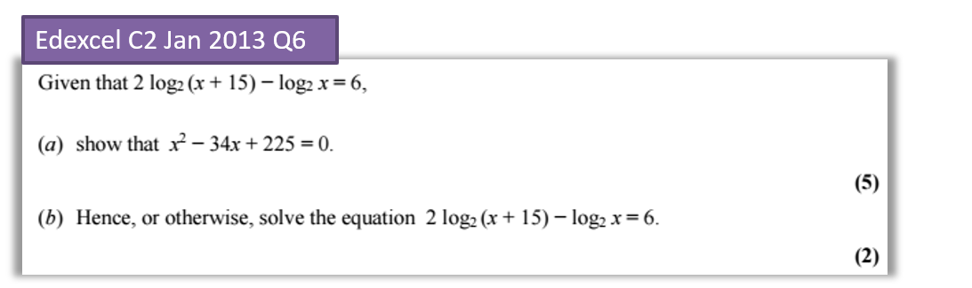

Exercise 14E Pg 323-324

AD Page 11
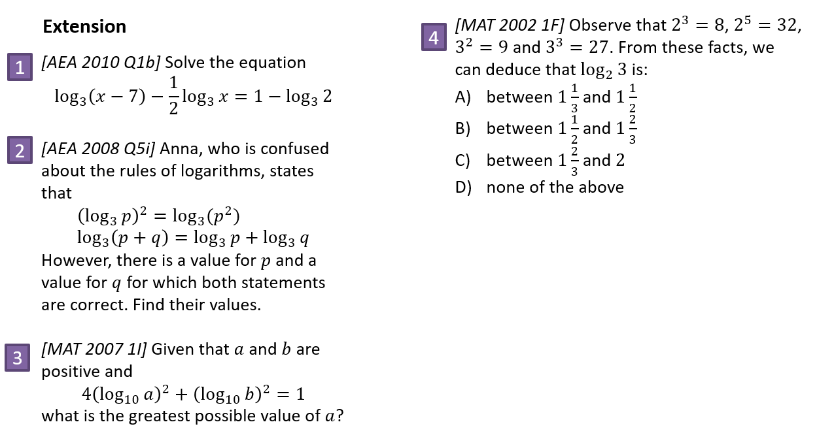

Solving equations with exponential terms
Solve $3^{x}=20$

Solve $5^{4x-1}=61$

Solve $3^{x}=2^{x+1}$

Solve the equation $5^{2x}-12\left(5^{x}\right)+20=0$, giving your answer to 3sf.

Solve $3^{2x-1}=5$, giving your answer to 3dp.

Solve $2^{x}3^{x+1}=5$, giving your answer in exact form.

Solve $3^{x+1}=4^{x-1}$, giving your answer to 3dp.

Exercise 14F Pg 325

AD Page 11
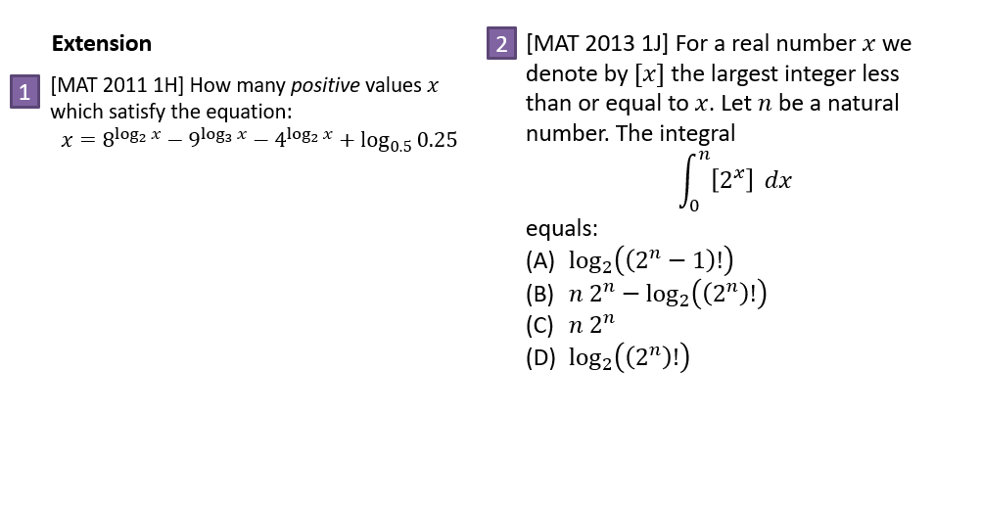

Natural logarithms
The inverse of $y=e^{x}$ is $y=\ln{x}$
$$\ln{e^{x}}=$$
$$e^{\ln{x}}=$$
Solve $e^{x}=5$

Solve $2\ln{x}+1=5$

Solve $e^{2x}+2e^{x}-15=0$

Solve $e^{x}-2e^{-x}=1$

Solve $\ln\left(3x+1\right)=2$

Solve $e^{2x}+5e^{x}=6$

Solve $2^{x}e^{x+1}=3$ giving your answer as an exact value.

Exercise 14G Pg 327-8

AD Page 11
Graphs for Exponential Data
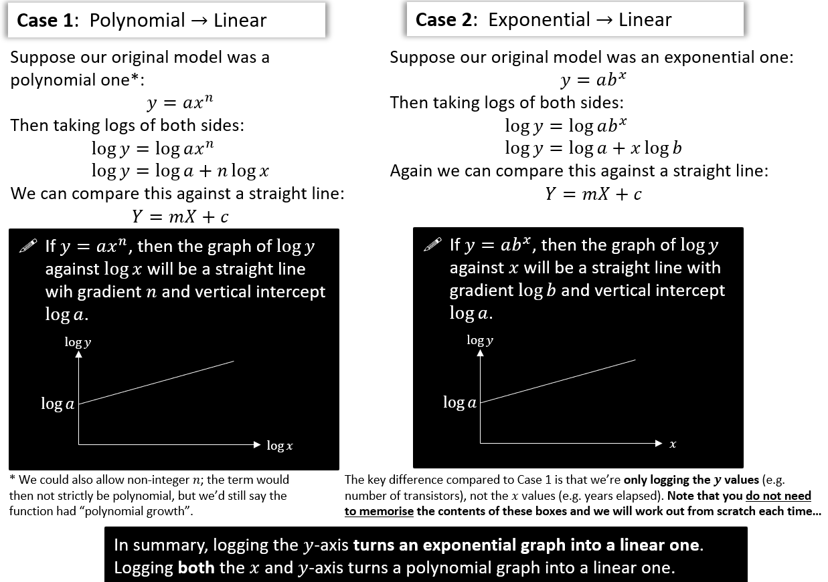
Turning non-linear graphs into linear ones

[Textbook] The graph represents the growth of a population of bacteria, $P$, over $t$ hours. The graph has a gradient of 0.6 and meets the vertical axis at $\left(0,2\right)$ as shown.
A scientist suggests that this growth can be modelled by the equation $P=ab^{t}$, where $a$ and $b$ are constants to be found.
- Write down an equation for the line.
- Using your answer to part (a) or otherwise, find the values of $a$ and $b$, giving them to 3 sf where necessary.
Interpret the meaning of the constant $a$ in this model.
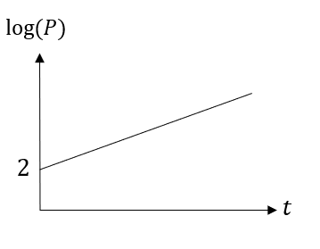

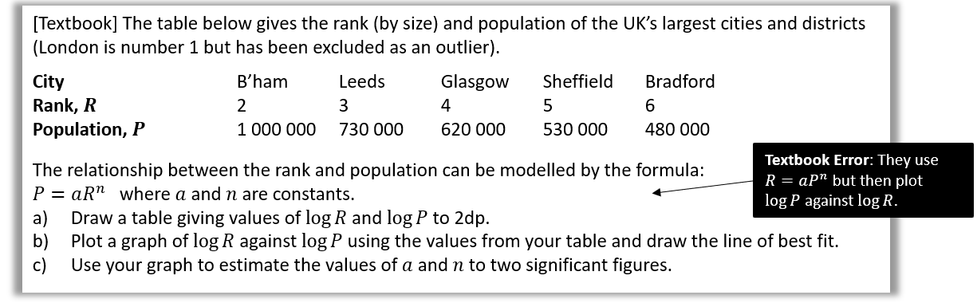

Dr Frost’s wants to predict his number of Twitter followers $P$ (@DrFrostMaths) $t$ years from the start 2015. He predicts that his followers will increase exponentially according to the model $P=ab^{t}$, where $a,b$ are constants that he wishes to find.
He records his followers at certain times. Here is the data:
Years $t$ after 2015: 0.7 1.3 2.2
Followers $P$: 2353 3673 7162
- Draw a table giving values of $t$ and $\log{P}$ (to 3dp).
- A line of best fit is drawn for the data in your new table, and it happens to go through the first data point above (where $t=0.7$) and last (where $t=2.2$).
Determine the equation of this line of best fit. (The $y$-intercept is 3.147)
- Hence, determine the values of $a$ and $b$ in the model.
- Estimate how many followers Dr Frost will have at the start of 2020 (when $t=5$).

Exercise 14H Pg 331-333

AD Page 11

