A Level Mathematics
Chapter 11 - Mechanics
Variable Acceleration
Chapter Overview
1. Functions of Time
2. Using Differentiation
3. Maxima and Minima Problems
4. Using Integration
5. Constant Acceleration Formulae

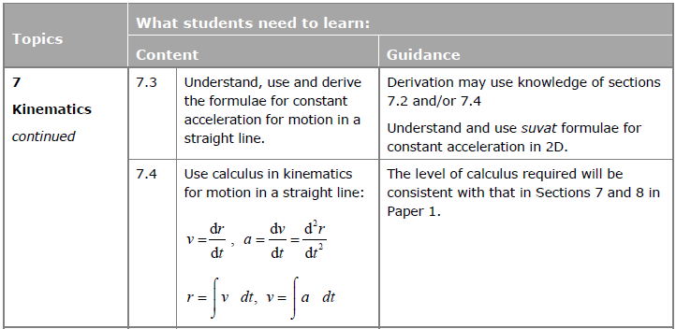

- Functions of Time
Up to now, the acceleration has always been constant in any particular period of time. However, it’s possible to specify either the displacement, velocity or acceleration as any function of time (i.e. an expression in terms of $t$). This allows the acceleration to constantly change.

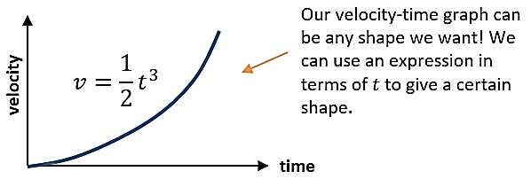
Example
The velocity-time graph of a body is shown above, where $v=\frac{1}{2}t^{3}$.
- What is the velocity after 4 seconds have elapsed?
- How many seconds have elapsed when the velocity of the body is $108$ ms⁻¹?

Example (Textbook)
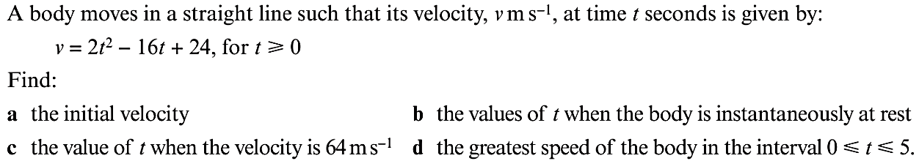

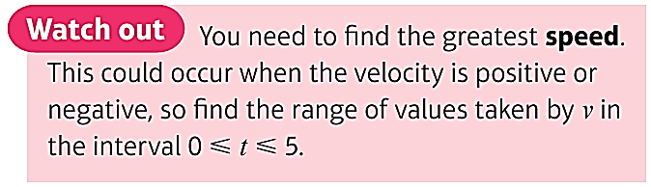
Exercise 11A Page 184

- Using Differentiation

$s$ (displacement)

$v$ (velocity)

$a$ (acceleration)

Example
A body moves in a straight line such that $v = 2t^{2} - 11t + 14$. Initially (i.e. when $t = 0$), the displacement of the body from some fixed point O on the line is 50m. Find:
a) The initial velocity of the body
b) The values of t when the body is at rest
c) The acceleration of the body when t = 5s
d) The displacement of the body when t = 6s (we cover integration later in the chapter)

Test Your Understanding
Pudding the Cat’s displacement from a house, in metres, is $t^{3}-\frac{3}{2}t^{2}-36t$ where $t$ is in seconds.
(a) Determine the velocity of the cat when $t=2$.
(b) At what time will the cat be instantaneously at rest?
(c) What is the cat’s acceleration after 5 seconds?

Exercise 11B Page 185

- Maxima and Minima Problems
Recall from Pure that at minimum/maximum points, the gradient is 0. We could therefore for example find where the velocity is minimum/maximum by finding when $\frac{dv}{dt}=0$ (i.e. when the acceleration is 0). Similarly, we can find the maximum and minimum values for displacement and acceleration.

Example
A particle P, moves in a straight line such that its velocity, $v ms^{-1}$ at time $t s$, is given by:
$v = 5 - 9t + 6t^{2} - t^{3}$ where $0≤t≤4$

a) Find the difference between the maximum and minimum velocities over this time interval
b) Sketch a velocity-time graph for the motion of P
c) Find the maximum acceleration over this time interval

Test Your Understanding
A dolphin escapes from Seaworld and its velocity as it speeds away from the park, is
$t^{3}-9t^{2}-48t+500$ (in ms⁻¹), until it reaches its maximum velocity, and then subsequently remains at this velocity.
- When does the dolphin reach its maximum velocity?
- What is this maximum velocity?

Test Your Understanding (EdExcel M2 June 2013 Q3a and b)
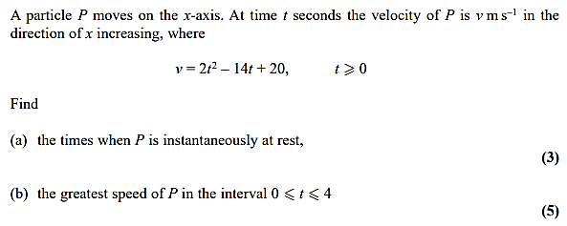

Test Your Understanding
A particle P, moves in a straight line. After t seconds, its distance, s m from its starting point A, when t = 0, is given by:
$s = 2t^{3} - 9t^{2} + 12t$ where $t≥0$
a) Show that the particle never returns to its starting point
b) Find the distances from A at which the particle is instantaneously at rest
c) Find the acceleration of the particle at time t = 3s

Exercise 11C Page 187

- Using Integration
If we know the acceleration, we can integrate to find expressions for velocity and displacement. Recall that the area under a velocity-time graph gives the displacement. Be careful if the velocity (and hence the area) falls under the t-axis as this will give negative displacement.

Example
A particle P, moves in a straight line. At t seconds its acceleration is $\left(6t + 12\right)ms^{-1}$. When t = 0, P is at the point A and its velocity is 3ms⁻¹.
a) Find an expression for the velocity of P in terms of t
b) Find the distance travelled between times t = 3 and t = 5

Example (Textbook Page 189 Example 7)
A particle travels in a straight line. After $t$ seconds its velocity, $v$ ms⁻¹, is given by
$v=5-3t^{2}$, $t≥0$. Find the distance travelled by the particle in the third second of its motion.

Test Your Understanding (EdExcel M2 June 2015 Q6)
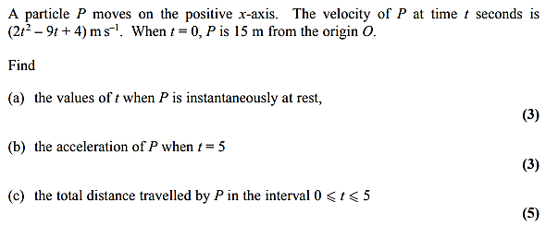

Exercise 11D Page 189

- Constant Acceleration Formulae
In Chapter 9, we work out the various $suvat$ formulae by using a velocity-time graph. But it’s also possible to derive all of these using integration, provided that we consider that acceleration is constant.

Given a body has constant acceleration $a$, initial velocity $u$ and its initial displacement is 0 m, prove that:
- Final velocity: $v=u+at$
- Displacement: $s=ut+\frac{1}{2}at^{2}$

Exercise 11E Page 192
Mixed Exercise 11 Page 193

