3-4. Constant Acceleration Formulae (SUVAT Equations)
These formulae are used to solve problems where the object is moving in a straight line with constant acceleration for a specific period of time. You should memorise these and know how to derive them.

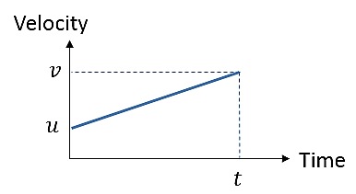

$$Acceleration=\frac{change in velocity}{time}$$

$v=$

(Equation 1)
For uniform acceleration, the average velocity is the average of v and u. Using the area of the graph (which we know gives distance):

$$s=$$

(Equation 2)
Eliminating v - sub for v from equation 1 into equation 2:

$$s=$$

(Equation 3)
Eliminating t - sub for t from equation 1 into equation 2:

$$v^{2}=$$

(Equation 4)

Eliminating u – sub for u from equation 1 into equation 2:

$s=$

(Equation 5)

- Work out what you know
- Work out what you need
- Choose the appropriate equation
- Diagrams help!
- Work out which direction will be positive
- Check that your units are consistent

Example
A stone slides in a straight line across a horizontal sheet of ice. It passes a point, A with velocity 14ms⁻¹ and a point, B 2.5 seconds later. Assuming the deceleration is uniform and that AB = 30m, find:
a) The deceleration
b) The velocity at B
c) How long after passing A the stone comes to rest

Example – Deceleration Leading to a Change in Direction
A particle travels with uniform deceleration 2ms⁻² in a horizontal line. The points A and B lie on the line and AB = 32m. At time t = 0, the particle passes through A with velocity 12ms⁻¹ in the direction AB. Find:
a) The values of t when the particle is at B
b) The velocity of the particle for each of these values of t.

Test Your Understanding (EdExcel M1 May 2013 Q4)
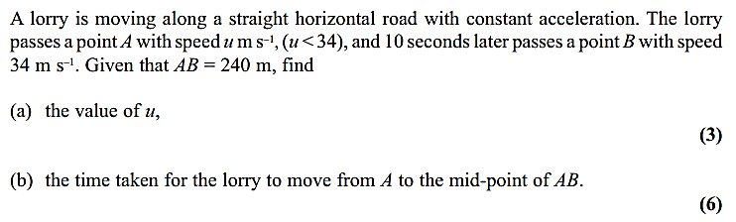
Exercise 9C Page 140
Exercise 9D Page 145

