9B Time-Speed Graphs

- The diagram below shows a velocity-time graph for the motion of a cyclist moving along a straight road for 12 seconds. For the first 8 seconds, she moves at a constant speed of 6ms⁻¹. She then decelerates at a constant rate, stopping after a further 4 seconds. Find:
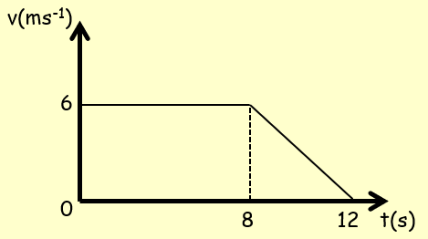
- The distance travelled by the cyclist

- The rate of deceleration of the cyclist

- A particle moves along a straight line. It accelerates uniformly from rest to a speed of 8ms⁻¹ in T seconds. The particle then travels at a constant speed for 5T seconds. It then decelerates to rest uniformly over the next 40 seconds.
- Sketch a velocity-time graph for this motion

- Given that the particle travels 600m, find the value of T

