9A Time-Distance Graphs

- A cyclist rides in a straight line for 20 minutes. She waits for half an hour, then returns in a straight line to her starting point in 15 minutes. Below is a displacement-time graph for her journey.
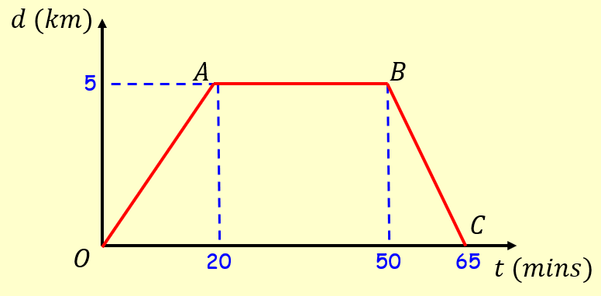
- Work out the average velocity for each stage of her journey, in kmh⁻¹

- Write down the average velocity for the whole journey

- Work out the average speed for the whole journey

