A Level Mathematics

Chapter 9 - Mechanics
Constant Acceleration
Chapter Overview
1. Displacement-Time Graphs
2. Velocity-Time Graphs
3. Constant Acceleration Formulae (SUVAT)
4. Vertical Motion Under Gravity

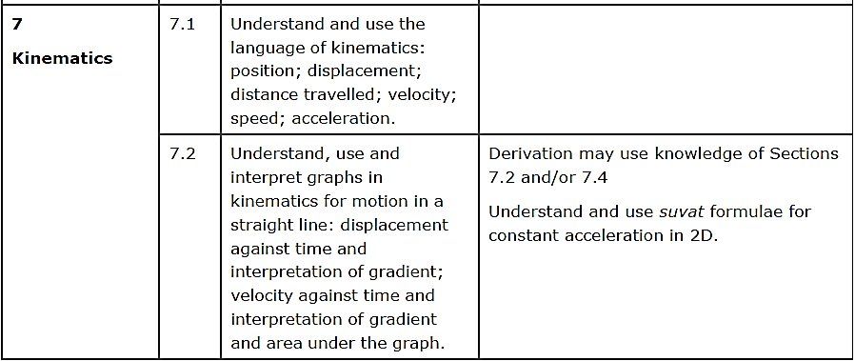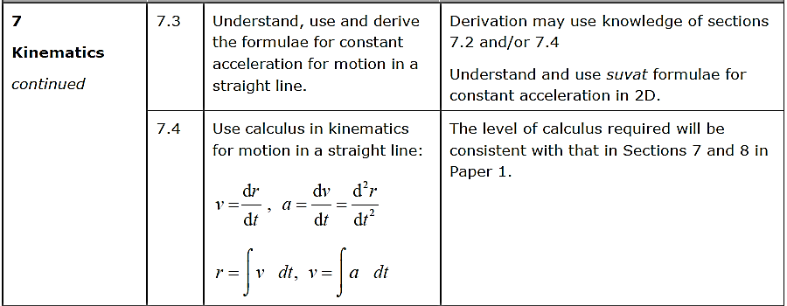

- Displacement-Time Graphs
Describe the motion of each object:

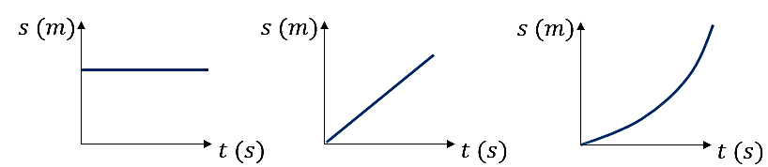

Velocity is the rate of change of displacement
(i.e. gradient of displacement-time graph)

Average Velocity = ___________________________

Average Speed = _________________________

Example (Exercise 9A Question 2)
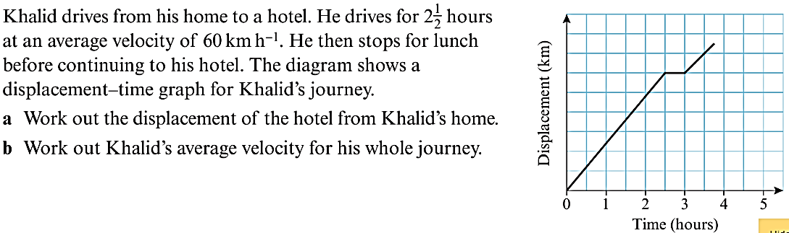

Exercise 9A Page 132

