8D Vectors

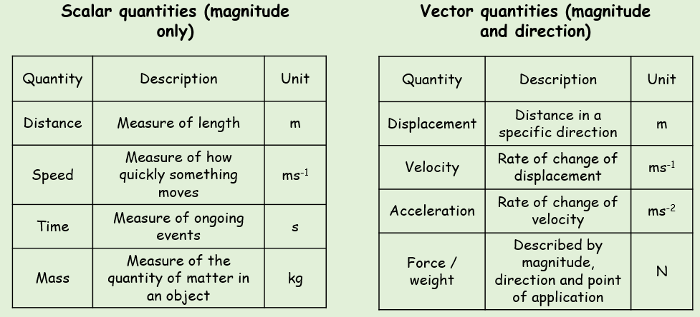

- Fully describe the motion of the particles below:
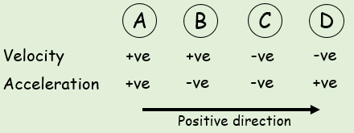

2D Notation

- The velocity of a particle is given by $v=3i+5j ms^{-1}$
Find:
- The speed of the particle

- The angle the direction of motion of the particle makes with the unit vector i.

- A man walks from A to B and then from B to C. His displacement from A to B is 6i + 4j km. His displacement from B to C is 5i – 12j km.
- What is the magnitude of the displacement from A to C?

- What is the total distance the man walked in getting from A to C?

