Working with Vectors
In Mechanics you will often need to convert to/from the scalar form of a quantity and the vector form.

SCALAR:

VECTOR:

Examples of scalars and vectors:
Scalar | Vector

NB: 1-dimensional vectors are still different from scalars. Consider the displacement on a 1-dimensional line in a particular direction. If we’d gone backwards 3 units…

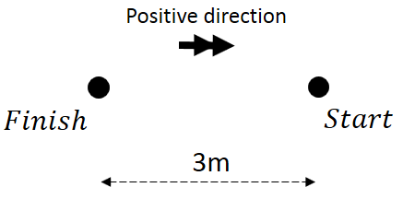
What is the distance travelled?

What is the displacement of the particle?

Vector Notation
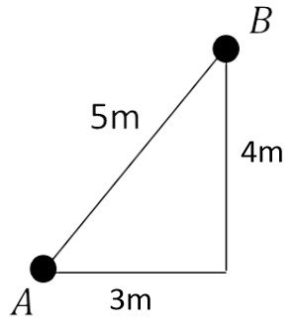

Column Notation i-j Notation
(i and j are unit vectors of length 1)

Adding and Subtracting Vectors
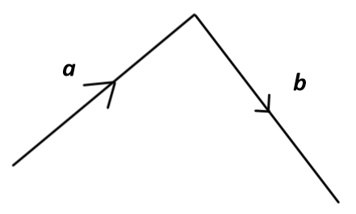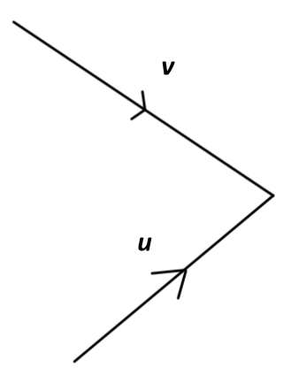

Two vectors are equal if they have the same magnitude and direction.

Two vectors are parallel if they have the same direction but different magnitudes.

Converting Between Vectors and Scalars
To convert to vector form, just use basic trigonometry to find the 𝑥 -change and 𝑦 -change.

Scalar (Distance) Vector (Displacement)

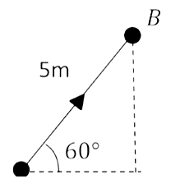

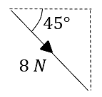

To convert scalar form, just find the magnitude of the vector using Pythagoras.

Vector (Velocity) Scalar (Speed)

$$\left(\begin{matrix}5 \\ -12\end{matrix}\right) ms^{-1}$$

Further Examples

Test Your Understanding
A woman walks from A to B and then from B to C.
Her displacement from A to B is 6i + 4j m.
Her displacement from B to C is 5i - 12j m.

a) What is the magnitude of the displacement from A to C?
b) What is the total distance the woman has walked in getting from A to C?
Exercise 8D Page 127
Mixed Exercise 8 Page 128

