8C SI Units

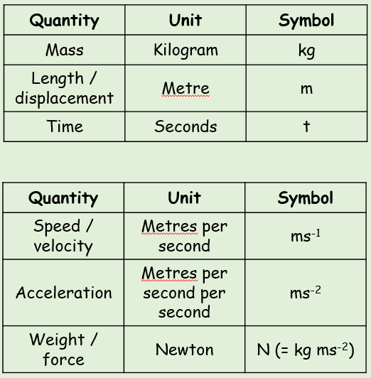

The Normal Reaction

Frictional Force

Tension

Thrust

Resistance

Gravity

Weight

Buoyancy

- Write the following quantities in SI units:
- 4km

- 0.32g

- 5.1 x 10⁶ kmh⁻¹

- The plane below is mid-flight. State the names of the labelled forces acting on it.

