Quantities and Units
The SI units are a standard system of units, used internationally (“Système International d’unités”). These are the base ones you will use:

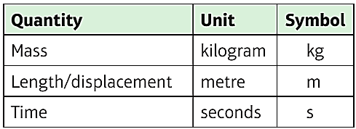
These derived units are compound units built from the base units.
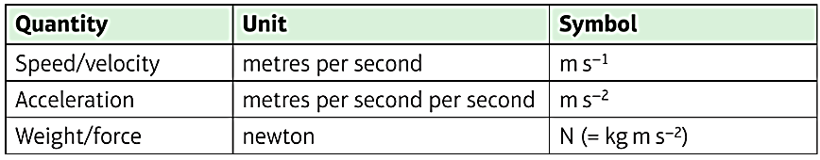
Can you convert 2.48 x 10⁵ kmh⁻¹ into SI units?

Types of Force and Force Diagrams
You will encounter a variety of forces in mechanics. It is ALWAYS helpful to draw a force diagram and make sure that you have included all forces acting on a body.

- Weight (always vertically downwards)
- Normal Reaction (always perpendicular to the surface of contact)
- Friction (only if the plane is ROUGH, always opposes motion)
- Tension (in a string – PULL force)
- Thrust/compression (e.g. in a rod or engine – PUSH force)
- Resistance (e.g. particle travelling through a liquid, always opposes direction of motion)
- Buoyancy (e.g. boat floating in water, always vertically upwards)

Force diagrams can be found on page 123 of the textbook.
Exercise 8C Page 124

