8B Modellings Assumptions

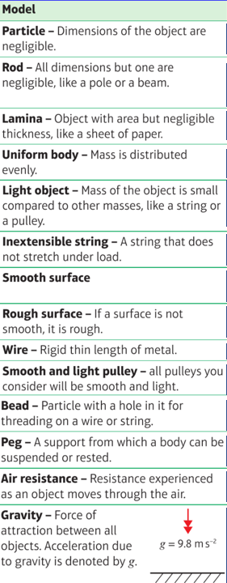

- A mass is attached to a length of string which is fixed to the ceiling. The mass is drawn to the side with the string taut and allowed to swing.
State the effect of the following assumptions on any calculations to be made:
- The string is light and inextensible

- The mass is modelled as a particle

