Modelling Assumptions
We make modelling assumptions to simplify a problem and solve it using known mathematical techniques. You must be able to understand how these assumptions will affect calculations versus the real-life situation.

A full list of modelling assumptions is on p121 of the textbook. The most common are shown below.

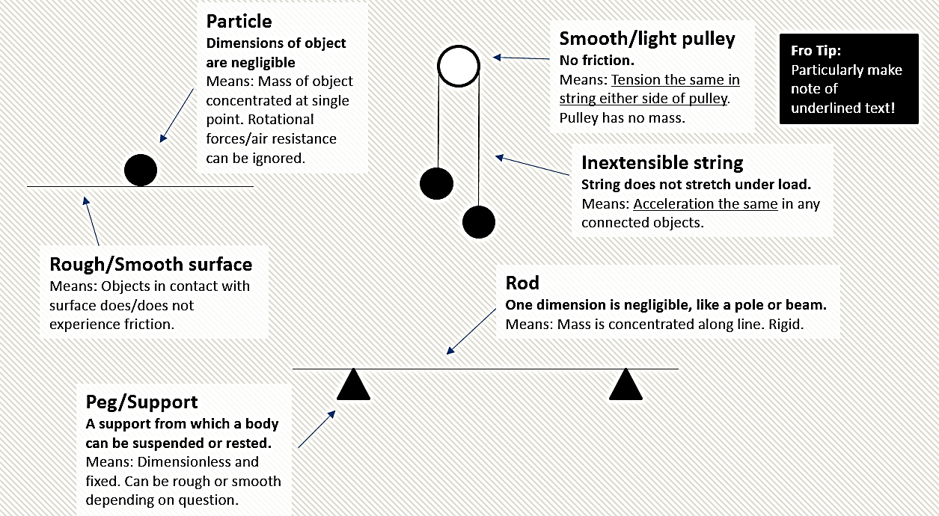

Example (Exercise 8B Question 2)
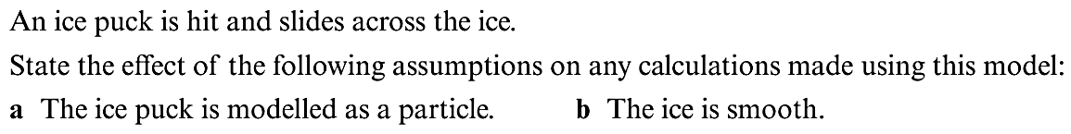

Exercise 8B Page 122

