A Level Mathematics

Chapter 8 - Mechanics
Modelling in Mechanics

Chapter Overview
1. Constructing a Model
2. Modelling Assumptions
3. Quantities and Units
4. Working with Vectors

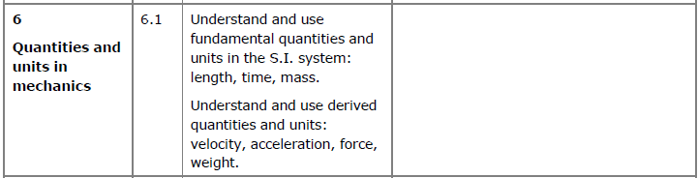

What is Mechanics?
Broadly speaking, mechanics covers motion, forces and how the two inter-relate with each other.
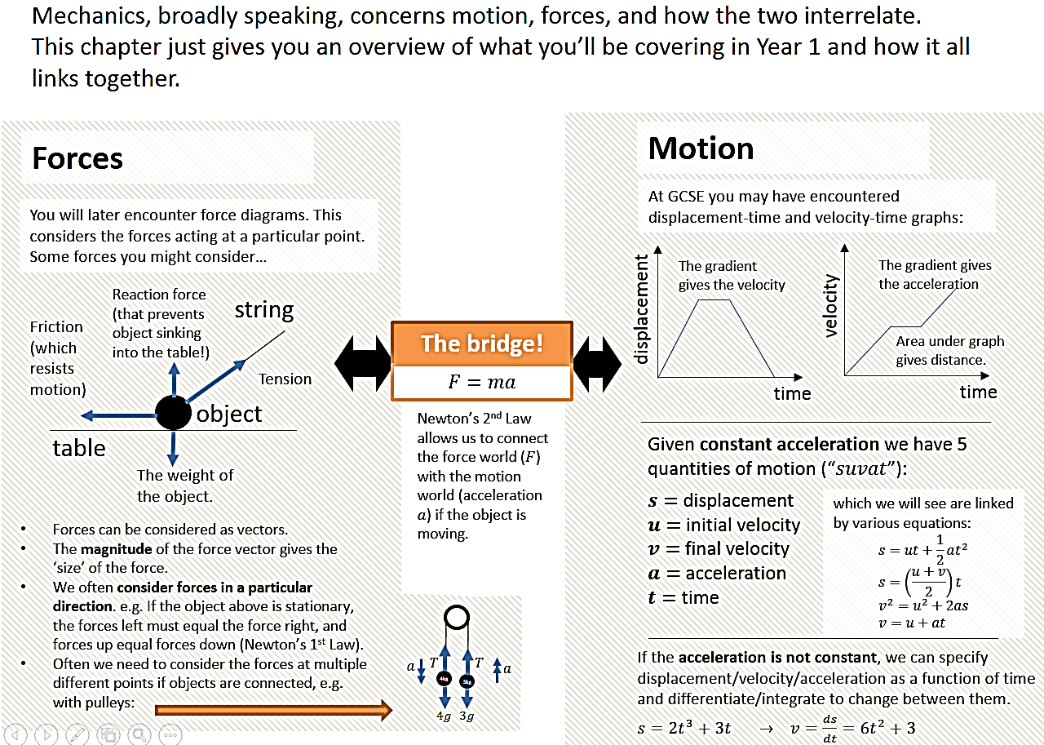
- Constructing a Model
Why use a mathematical model?

The solution to a mathematical model needs to be interpreted in the context of the original problem. You may need to refine the model and reconsider your original assumptions.

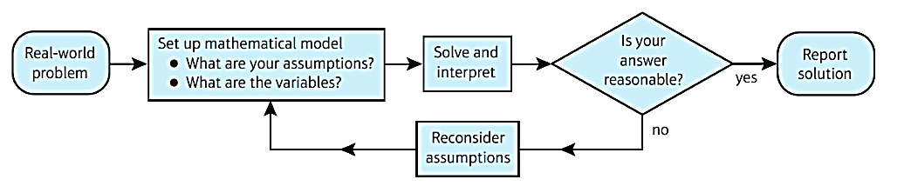
Example (Textbook)
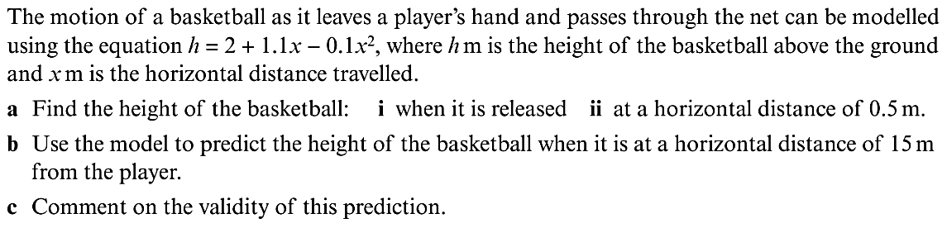

Exercise 8A Page 119

