7B Critical Regions

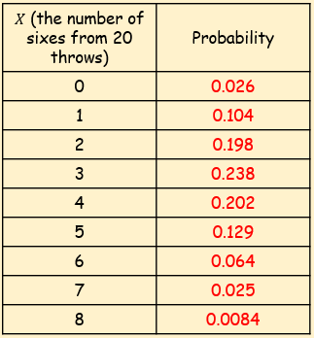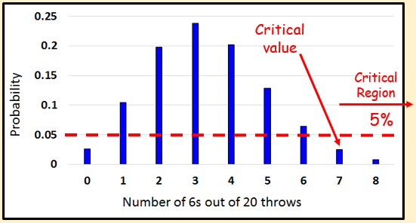

- A single observation is taken from a Binomial distribution $B(6, p)$. The observation is then used to test $H_{0}:p=0.35$ against $H_{1}:p>0.35$.

- Using a 5% significance level, find the critical region for this test

- State the actual significance level of this test

- A random variable $X$ has binomial distribution $B(40, p)$. A single observation in used to test $H_{0}:p=0.25$ against $H_{1}:p≠0.25$.
- Using the 2% level of significance, find the critical region of this test. The probability in each ‘tail’ should be as close to possible as 0.01

- State the actual significance level of the test

