A Level Mathematics
Chapter 7 - Statistics
Hypothesis Testing

Chapter Overview
- Hypothesis Testing
- Finding Critical Values
- One-Tailed Tests
- Two-Tailed Tests
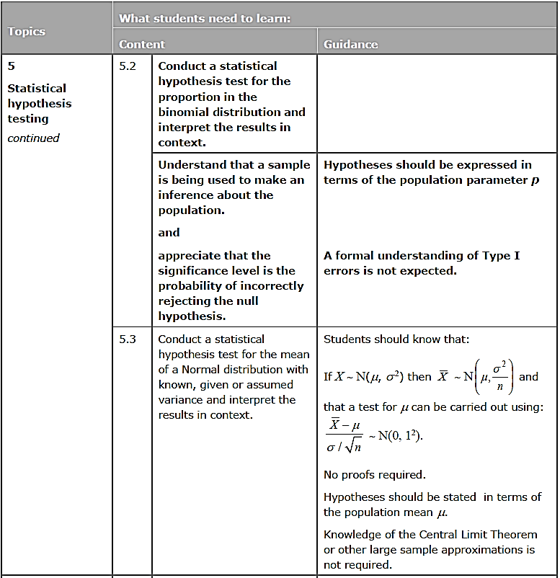

- Hypothesis Testing
What is Hypothesis Testing?
Vocabulary:
Hypothesis = statement about the value of a population parameter
Test Statistic = the result of the experiment, or the statistic that is
calculated from the example
Null Hypothesis, H₀ = the hypothesis you assume is correct
Alternative Hypothesis, H₁ = tells you about the parameter if your
assumption is shown to be wrong

Example
10% of the world’s population are left-handed. On my holiday to Hawaii, I want to establish if the proportion of left-handed people in Hawaii is greater than the world average. I have a table of 20 people as my sample. I need to ensure any result I get is statistically significant.

1) What is the hypothesis?

2) What is the population parameter?

In my sample of 20 people in Hawaii, I find that 5 are left-handed.
3) Suggest a null hypothesis (the hypothesis I assume is correct)

4) Suggest an alternative hypothesis (what happens to my parameter if my assumption is wrong)

5) What is the test statistic?

