7A Hypothesis Testing

- Imagine we believe that a dice is biased towards landing on 6s.
We roll the dice 20 times and get a 6 on 8 occasions
- What is the test statistic for this situation?

- Write a sensible null hypothesis for this situation

- Write a sensible alternative hypothesis for this situation

- A researcher wants to test, at the 5% significance level, whether the dice is biased
Under what conditions would we reject the null hypothesis?

- What is the probability of getting 8 sixes when rolling a dice 20 times?

Imagine we had rolled 7 sixes instead…

Imagine we had rolled 6 sixes instead…

- John wants to see whether a coin is unbiased, or whether it is biased towards coming down on heads. He tosses the coin 8 times and counts the numbers of times, $X$, that it lands heads up.
- Describe the test statistic

- Write down a suitable null hypothesis

- Write down a suitable alternative hypothesis

- An election candidate believe she has the support of 40% of the residents in a particular town. A researcher wants to test, at the 5% significance level, whether the candidate is overestimating her support. The researcher asks 20 people whether they support the candidate, and 3 say that they do.
- Write down a suitable test statistic

- Write down two suitable hypotheses

- Explain the condition under which the null hypothesis would be rejected

7B Critical Regions

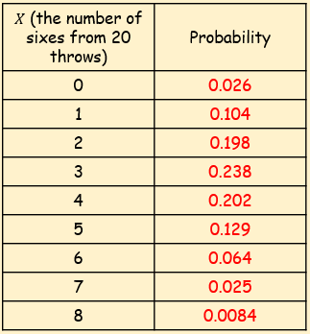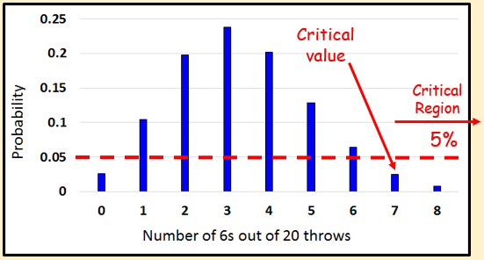

- A single observation is taken from a Binomial distribution $B(6, p)$. The observation is then used to test $H_{0}:p=0.35$ against $H_{1}:p>0.35$.

- Using a 5% significance level, find the critical region for this test

- State the actual significance level of this test

- A random variable $X$ has binomial distribution $B(40, p)$. A single observation in used to test $H_{0}:p=0.25$ against $H_{1}:p≠0.25$.
- Using the 2% level of significance, find the critical region of this test. The probability in each ‘tail’ should be as close to possible as 0.01

- State the actual significance level of the test

7C One-Tailed Tests

- A single observation, $x$, is taken from a Binomial distribution $B(12,p)$ and a value of 8 is obtained. Use this observation to test $H_{0}:p=0.4$ against $H_{1}:p>0.4$ using a 5% significance level.

- The standard treatment for a particular disease has a $\frac{1}{4}$ probability of success. A certain doctor has undertaken research in this area and has produced a new drug which has been successful with 10 out of 20 patients. The doctor claims that the new drug represents an improvement on the standard treatment. Test, at the 5% significance level, the claim made by the doctor.

7D Two-Tailed Tests

- A single observation, $x$, is taken from a Binomial distribution $B\left(10,p\right)$, and a value of 1 is obtained. Use this observation to test $H_{0}:p=0.45$ against $H_{1}:p≠0.45$ using a 5% significance level.

- Over a long period of time it has been found that in Enrico’s restaurant the ratio of non-vegetarian to vegetarian meals sold is 2:1. In Manuel’s restaurant, in a random sample of 12 people ordering meals, 2 ordered a vegetarian meal. Using a 5% significance level, test whether or not the proportion of people eating vegetarian meals in Manuel’s restaurant is different to that in Enrico’s restaurant.

