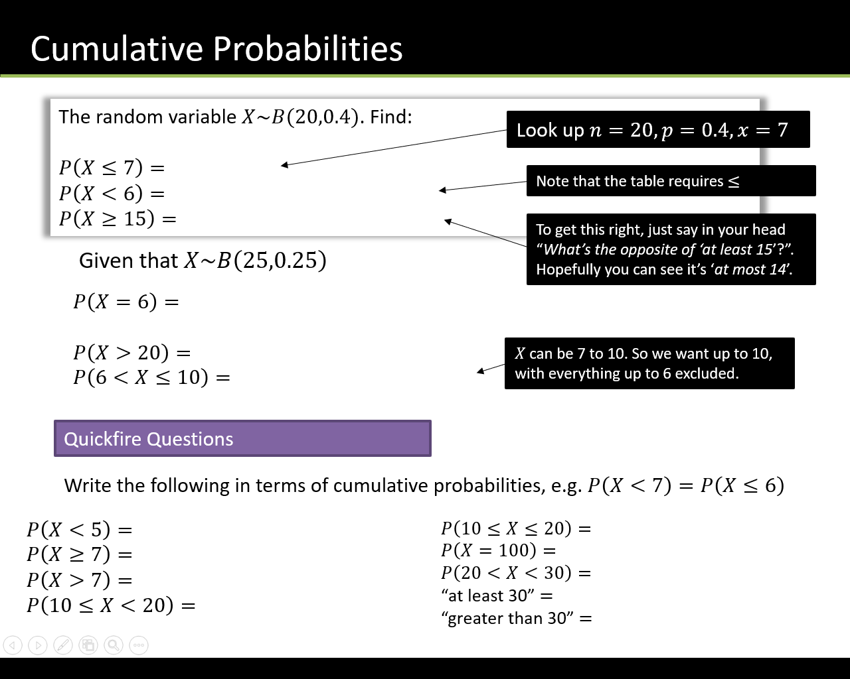

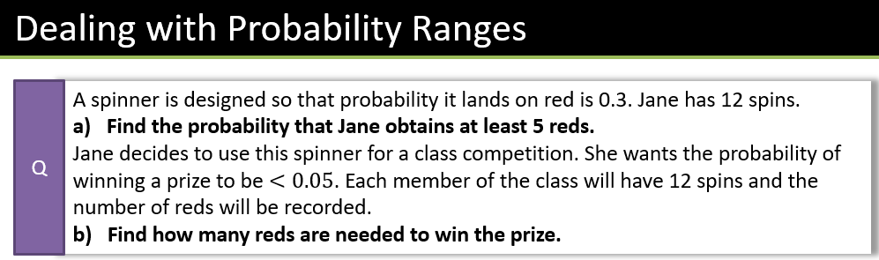

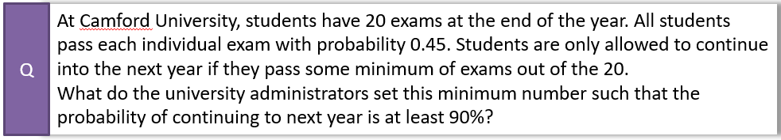

Textbook Exercise 6C Pg 93

