



The random variable $X\sim B\left(12,\frac{1}{6}\right)$. Find:



$P\left(X=2\right)$

$P\left(X=9\right)$

$P\left(X≤1\right)$

A company claims that a quarter of the bolts sent to them are faulty. To test this claim the number of faulty bolts in a random sample of 50 is recorded.

(a) Give two reasons why a binomial distribution may be a suitable model for the number of faulty bolts in the sample. (2)

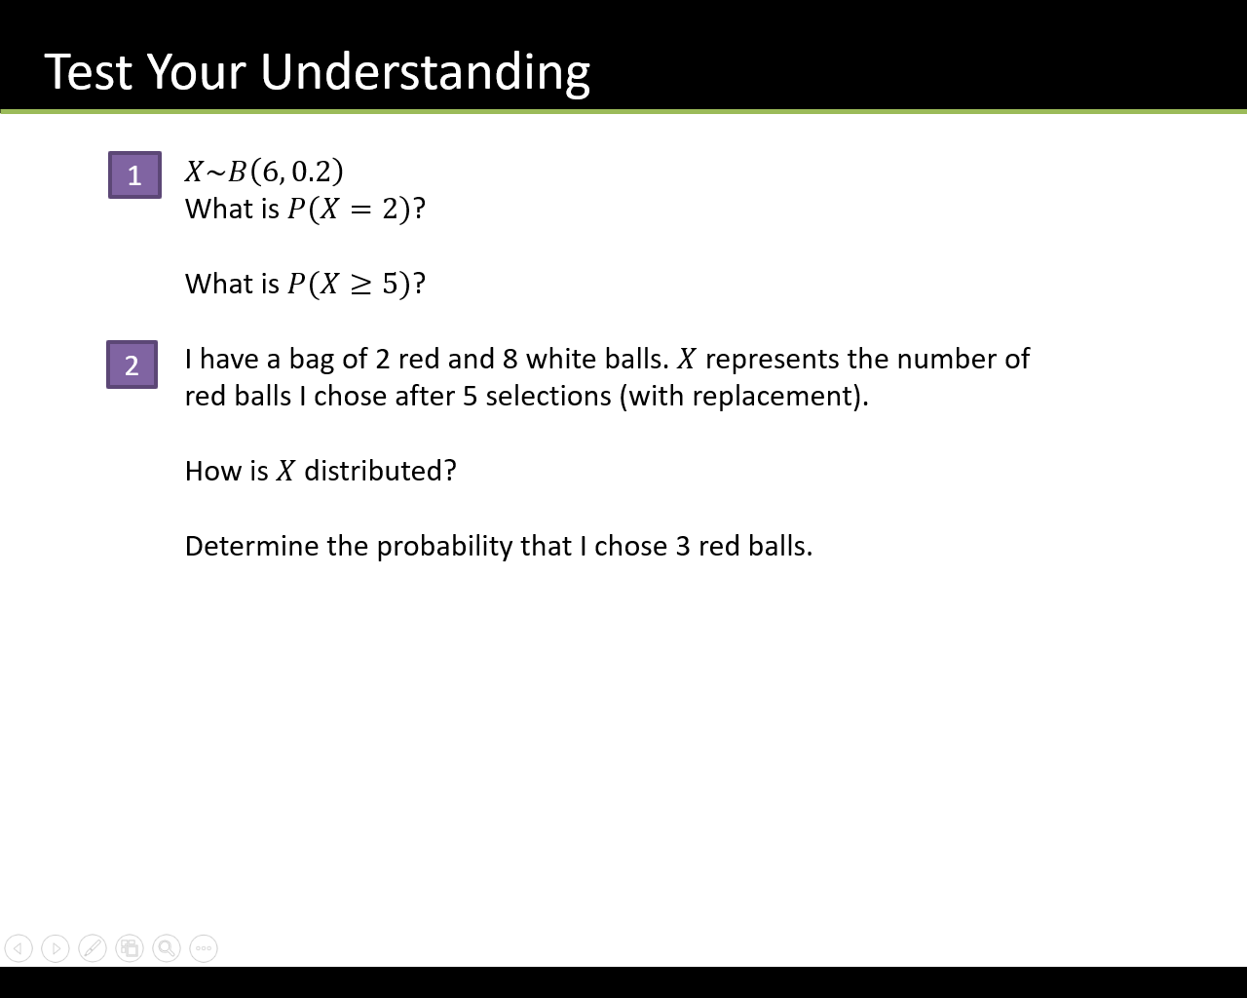

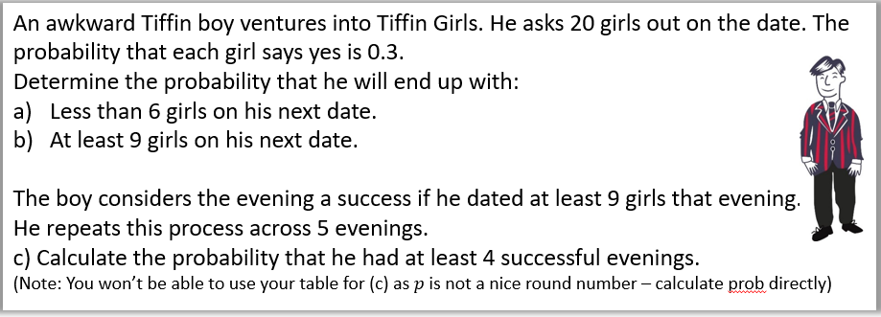

Textbook Exercise 6B Pg 90