Small Angle Approximations

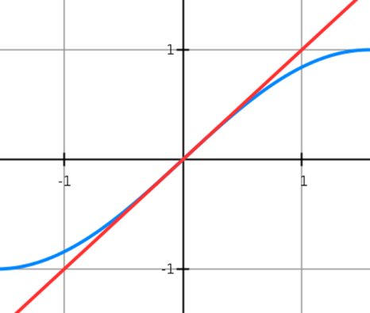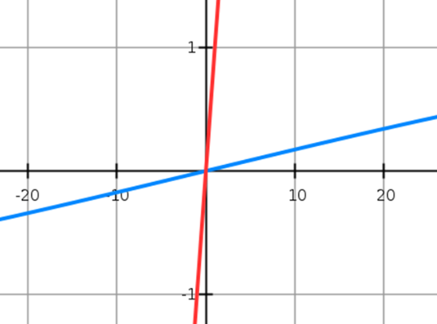

Example
When $θ$ is small, find the approximate value of:
- $\frac{\sin{2θ}+\tan{θ}}{2θ}$

- $\frac{\cos{4θ}-1}{θ\sin{2θ}}$

Example
a) Show that, when $θ$ is small,
$$\sin{5θ}+\tan{2θ}-\cos{2θ}≈2θ^{2}+7θ-1$$
b) Hence state the approximate value of
$\sin{5θ}+\tan{2θ}-\cos{2θ}$ for small values of $θ$.
Ex 5F Pg 134

