5D Area of Sectors & Segments
Sectors
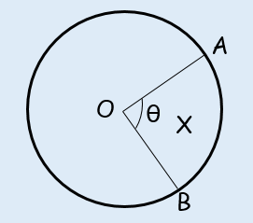

Segments
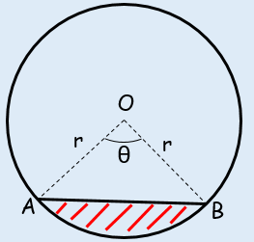

- In the diagram, the area of the minor sector AOB is 28.9cm². Given that angle AOB is 0.8 rad, calculate the value of r.
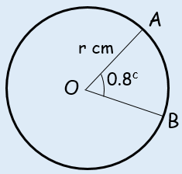

- A plot of land is in the shape of a sector of a circle of radius 55m. The length of fencing that is needed to enclose the land is 176m. Calculate the area of the plot of land.

- Calculate the Area of the segment shown in the diagram below.
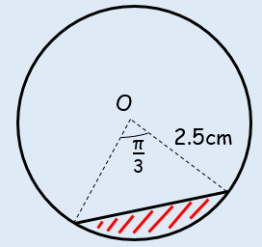

- In the diagram AB is the diameter of a circle of radius r cm, and angle BOC = θ radians. Given that the Area of triangle AOC is 3 times that of the shaded segment, show that 3θ –4sinθ = 0.
